




THE PROMISE OF REST

“ See, I will make all things new…..” (Revelation 21:5)

God wants people to know that he is searching like a shepherd and waiting like a father. He is willing to forgive and accept at his children all who live by the simple plan he has given. God invited us to get involved with Him in His Work. God has a big purpose for our life – a very specific and significant calling for us to fulfill. If we want to know how to deal with difficult people, then God tells us clearly:

“Love your enemies and pray for those who persecute you”


Videoblog : jaipalbehl | Fest21.com
Bottom of Form
GOD IS WONDERFUL!
His Love endures forever,
His faithfulness continues through all generations.

SUBJECT: “The Greatest Love Story of the World.”
A FILM SECTION ON WORLD INTEGRATION NON- VIOLENCE, LOVE AND PEACE

Respected Sir,

On this noble and beautiful occasion, I thank Almighty God, the Supreme Ruler of the entire Universe, for having given me an opportunity to express my views on ‘World Peace'

I feel much pleasure in submitting my material on “REST-WORLD PEACE.”
Sir, I bring to show you real “The Greatest Love Story of the World.” There in neither any script nor any humor – it is based on the blessings of the Lord.

- It is worth mentioning here that the recommendation of a seven member jury, worthy Sh. Jagdish Gandhi Ji, President of the World Movement for Global Democracy, and he announced of World Peace Film Awards 2007, and I was placed at Sr. No. 8 under commendable efforts for “Vocal War - World Peace”.
- The nominations for the awards were received for the World Movement for Global Democracy during in 4th Global Symposium: ‘Awakening Planetary Consciousness’ and 8th International Conference of Chief Justices of the World.
- With the grace of God, I am the ONLY person from India who has been bestowed with such commendable efforts for contribution on World Peace. (Document copies enclosed for your information please).

With best regards

Enclosed: Yours Sincerely
1. ENTRY FORM
2. Documents Copies Jai Pal Behl, #1888/F
3. ‘World Peace’ Sector-7/C, Chandigarh (India)
- A Train of Love. Mobile: 9914011555
4. PAIGAM (The Message)

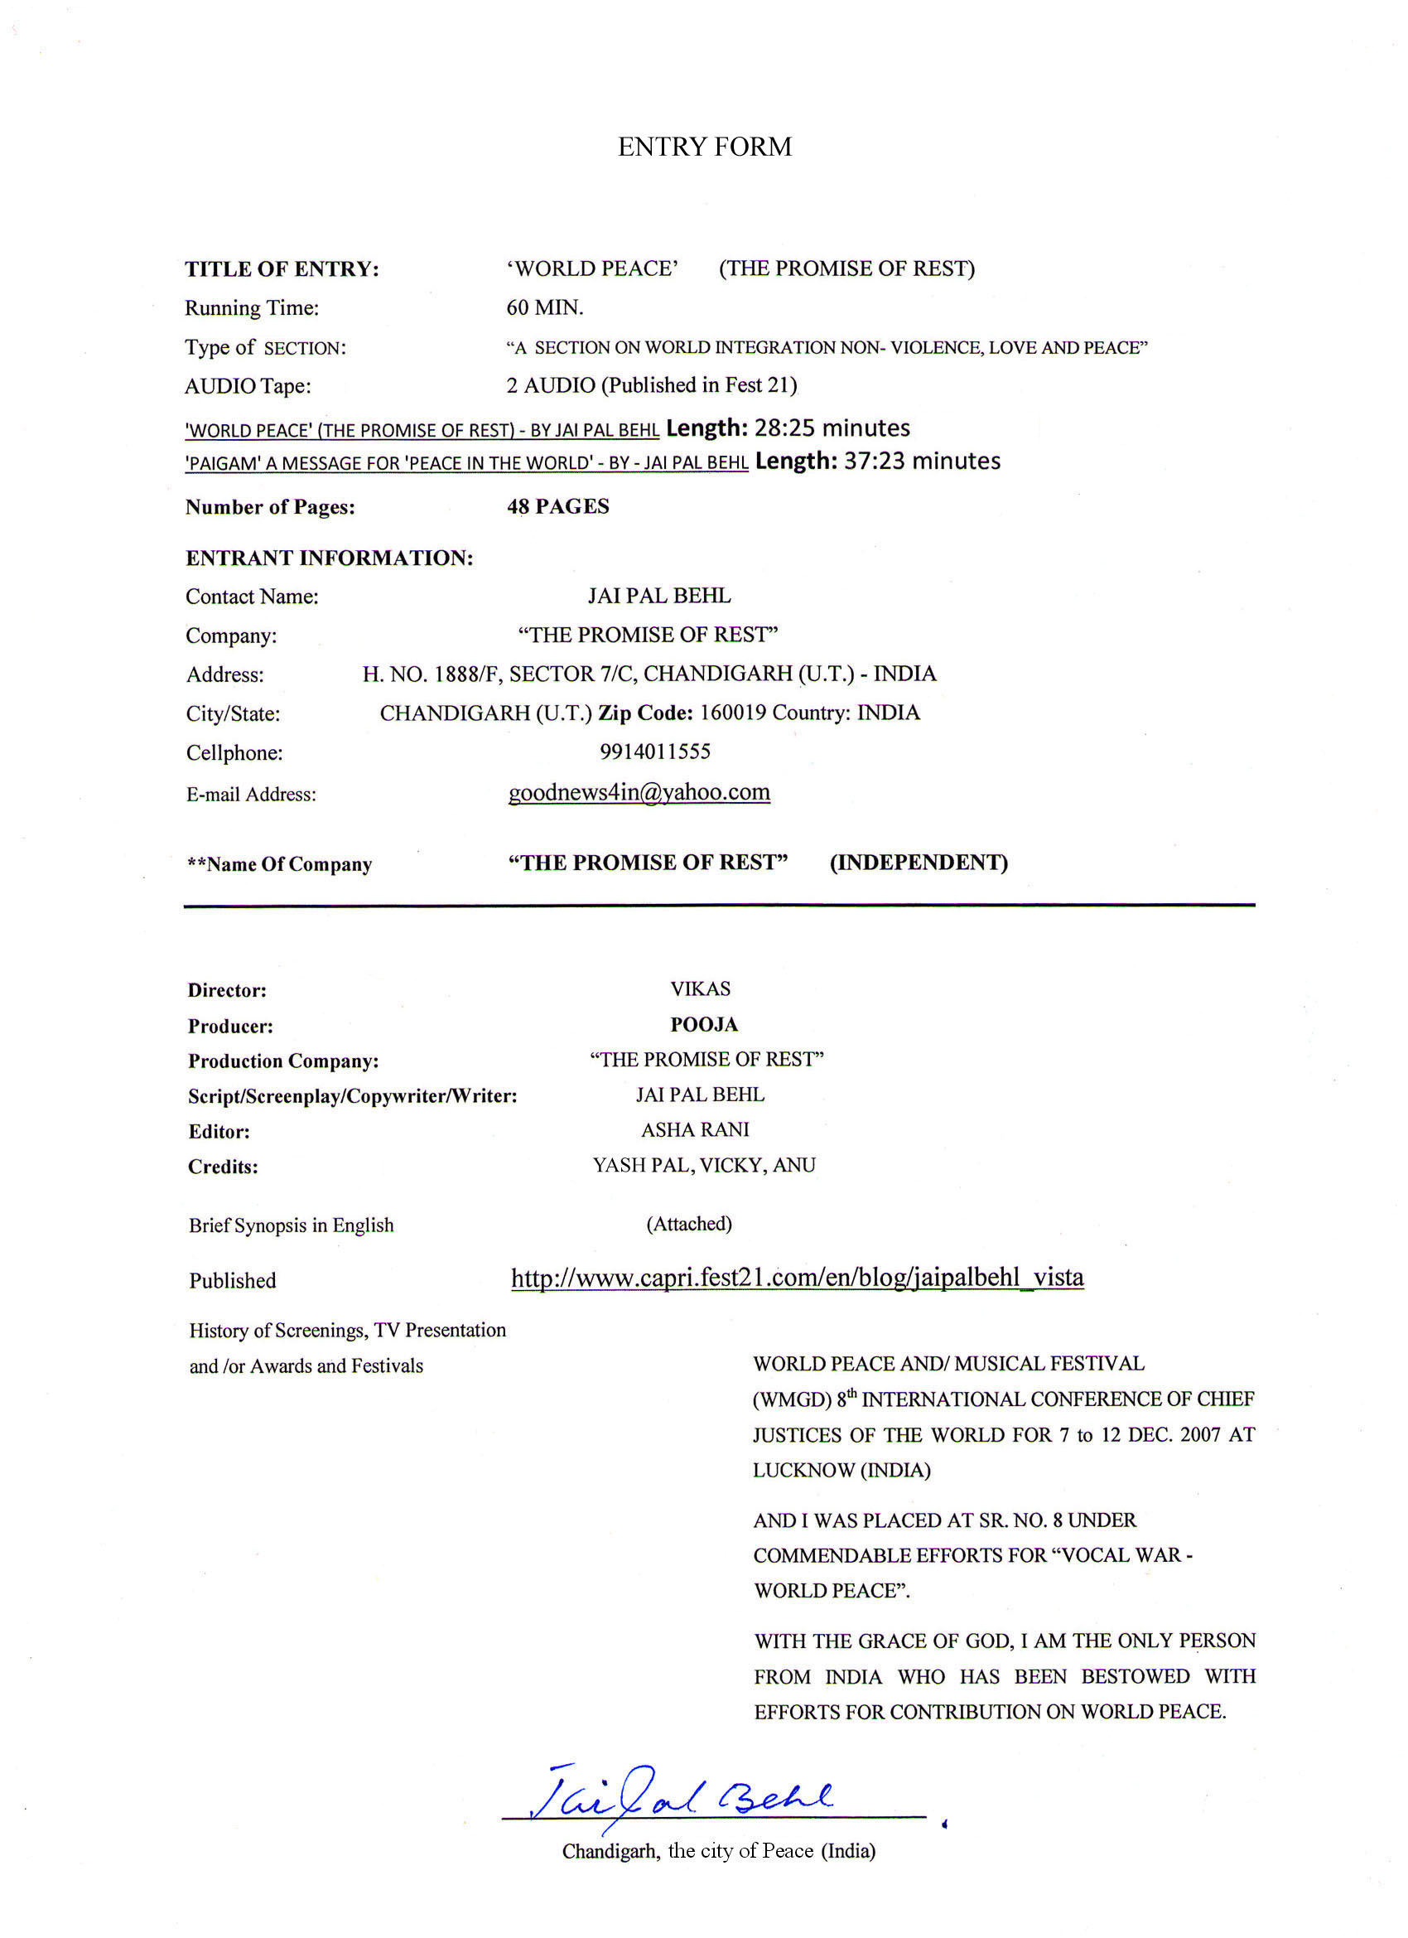

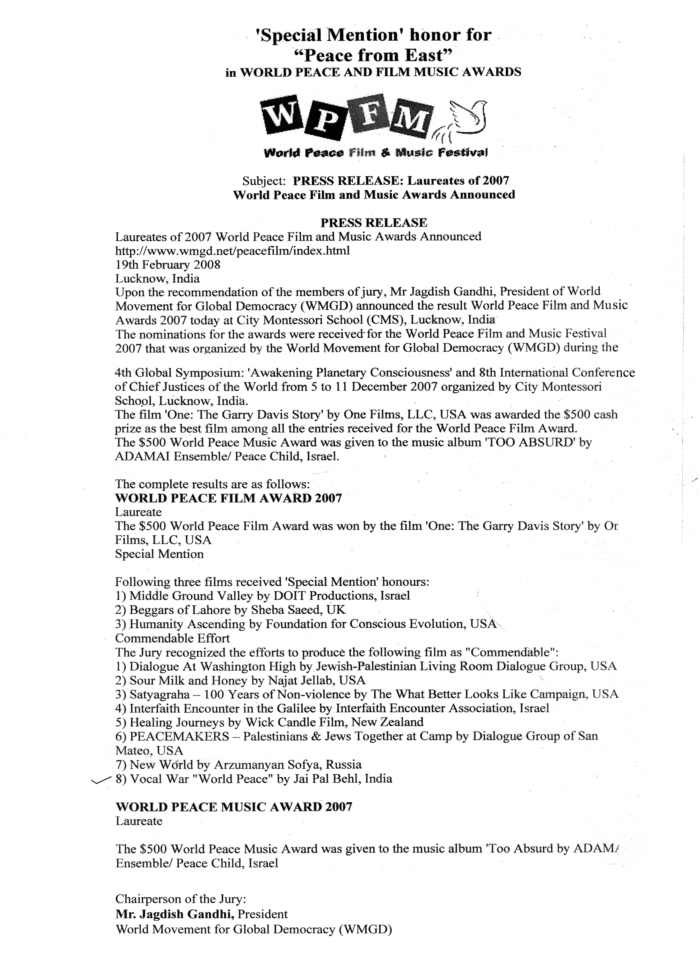

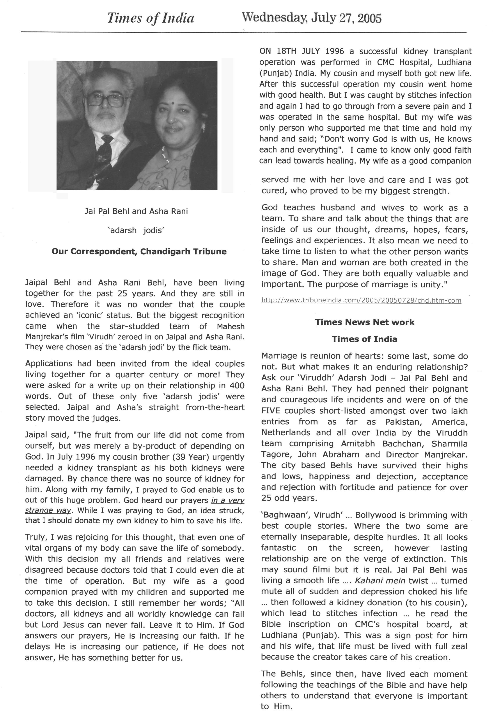

“REST-WORLD PEACE”
BRIEF SUMMARY OF THE BOOK “REST-WORLD PEACE”
SHORT BIOGRAPHICAL SKETCH OF MYSELF JAI PAL BEHL AND THAT OF MY WIFE MRS. ASHA RANI

I introduce myself Jai Pal Behl S/o Late Shri Bharat Lal Behl who was a Great Freedom Fighter. He launched a News Paper “SARFROSH”. I still remember his dying words, “After my pen stops bring your pen in action, so that my spirit remains alive through your pen. The best way to find yourself is to loss yourself in the service of others. Do everything in such a way that every work is entirely dependent on you.”

That Kidney of my cousin failed and operation for the same had to be performed on 18, July, 1996 in CMC Hospital, Ludhiana (Punjab). Nobody came forward to donate his Kidney .Along with my family, I prayed. God heard our prayers in a very strange way that I should donate my own Kidney for him .Truly, I was rejoicing for this thought, that even one vital organs of my body can save the life of my brother. When I tried to donate my Kidney, all of my relatives /friends prohibited me from doing so. The only one person, my wife came forward and prompted me to do so, she was said, “Don’t worry, God is with us. He knows each and everything.” My wife gave me requisite courage to face this ordeal and as result, I donor and donee were both cure of this sudden at this requirement. My wife is a good companion served me with her love, and she proved to be my biggest strength. We decided to live for society and die for Him, and donate our eyes after death so that God may use our eyes for others.

We notice in the society that the divorce rate is very high .Even the highly educated persons are following this ugly practice and are violating the commands of God. A beautiful an idea struck to my wife that we should take one by one such case (divorce). In order to reduce this high rate, we visited many courts and houses those were affected and explained to them the greatness and glory of married life. God teaches husbands and wives together as a team. They are committed to each other until death (Matthew 19:6; 1 Cor 7:39). They are no longer two but one. Therefore what God has joined together, let man not separate. With the grace of God we united several broken homes and bring cheer and sunshine into many others. In present my wife is encouraging and helping me to spread peace message in the world.

Brief summary of the Book ‘Rest-World Peace’ the story of Adam and Eve, the fruit of the serpent, express deep and per- found truths about the human situations. The first man and woman disobeyed God. Bible uses to describe human disobedience is ‘Sin’. God is good, and we are all creative in his image. But that image has been fatally spoiled by sin. Sin was present in the universe before the fall of Adam and Eve. As per God, sins are more than cancer cells, because cancer cell grow multiply, and take over major surgery may be needed to save our life. So the most terrible, the most divesting fact of universe is sin. The cause of all trouble, the root of all sorrow, and kind of all disease the dread of every man lies in this small word sin. It has reversed the nature of man. It has destroyed the inner harmony of man’s life. It has robbed him of his nobility. All mental disorders, all kind of sickness all destruction, all wars find their root in sin. It causes madness in the brain and poison in the heart. God looked down from heaven and saw all the hatred, sickness, fear sin and sadness, and in his great love he sent his son to be born in a stable. God had made provisions for their failure even before they were brought into existence. He knew that no mortal could compensate for the evil of sin, and in his justice. In his great love for his creation promoted Him to make the terrible sacrifice of His own eternal son (Jesus), so that the sins of man might be erased.
It is not a single agency which can eradicate the evil and menace of terrorism and achieve this motive of bringing the entire universe on a single pedestal where all people of the world may rest in peace and prosperity. It goes without any doubt the peace were preached by Jesus Christ, “Love your enemies and pray for those who persecute” (Matthew 5.44), was followed by Mahatma Gandhi Ji who strictly believed in Non-Violence. Today madness cannot be dealt with by hiring more policemen to monitor and arrest offenders and then building bigger prisons to hold them. The truth is that the result of the fruit of evil manifesting in destruction. The negative judgments that are in our world, manifesting in violence, terrorist acts, fires etc., are result broken spiritual laws. The importance of peace cannot be over – emphasized, let enlightenment dawn on the masses and the terrorists may themselves realize, that they possessed with some evilish spirit. A person is not criminal by birth but circumstances force them to adopt wrong path. Jesus told, “It is not the healthy who need a doctor, but the sick, I have not come to call the righteous, but sinners to repentance.” Yet it is quite different from the universal message of the Almighty God to the mankind, which is to ‘Love your enemies’, and not to take revenge, i.e. death for death.

In the world our youth is energy.
May the God of Hope divert our world youth into a positivety of life, So that they may work out in constructive manner. Amen.
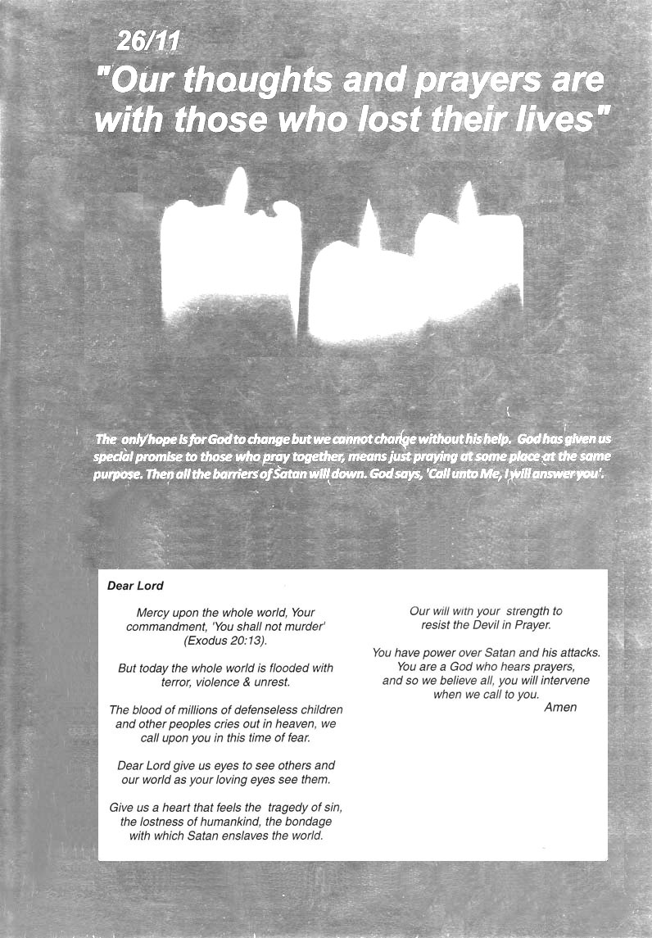
SONGS FOR SORROW AS WELL AS JOY
Dear Lord, “You are my hiding place; you will protect me from trouble
And surrounded me with songs of deliverance” (Psalm 32:7)

All of us know that our world needs love and affection. A child needs love, friends, strangers and nations need love. Loves for humanity prove the fact that love is the greatest healer and brings happiness to all. 26/11 test of our patience. Our thoughts and prayers are with those who lost their lives, no fault of theirs, and also their families and their loved ones. We all salute, all our valiant officers, who have made the supreme sacrifice for the nation.

In the book of Psalm, all songs capture the innermost thoughts and progress of Old Testament people - and they still speak directly to our needs. The Psalm wrestles with the deepest sorrow and ask God the hardest questions about suffering and injustice. For every emotion mood, we find, in almost every Psalm the presence of God, not as a philosophical principle, but as an active, strong, and loving ruler - a God, who makes a difference in life. The Psalm writers frequently asked, “Where are you, God? Why don’t you help me?” Despite their love of God, they often felt abandoned, miscued betrayed they found no guarantee of safety in their closeness to God.

The joy and praise that saturate these prayers came, not from an absence of problems, but from a deep conviction that a great God would overcome them one day. The powerful poems of praise and worship, offer no magical formulas to make troubles go away. Yet, while real life questions, struggles and discouragements have a strong voice in these poems, but dears, more powerful still is the voice of joy and security in the strength and power of God. The work of God’s hands is evidence of his marvelous glory. The beauty and holiness of God is called His glory, as shown in his creation a Psalm of king David is 19,24: The heavens declare the glory of God; the skies proclaim the work of his hands. Day after day they pour for speech; night after night they display knowledge. In the heavens he has pitched a tent for sun, which like a bridegroom coming for from his pavilion like a champion rejoicing to run his course. It rises at one and of the heavens and makes its circuit to the other; nothing is hidden from its heat. The law of the LORD is perfect, reviving the soul. The statues of the LORD are trust worthy and giving joy to the heart. The commands of the LORD are sure and altogether righteous than gold than much pure gold; they are sweeter than honey. The earth is the LORD’s and everything in it, the world, and all who live in it; for he founded it upon the seas and established it upon the waters. Lift up your heads, O you gates; that the king of glory may come in. Who is this King of glory? The LORD Almighty – he is the King of glory.

My mind at this time is all thankful to God; especially when I think about it that due to a car accident when I was surrounded by chains of death, when my soul fainted within me. I remembered the Lord, and God pulled me out of those chains, and He gave me more time in life that I may present His love for mankind of His Gift. GOD IS WONDERFUL! His Love endures forever, His faithfulness continues through all generations. God did not create the world and then leave it to function on its own. He has been actively involved throughout history. God’s word, teaches us that man is totally unique among all of God’s creatures. We are the only beings created in the image and likeness of God. We are given the capability of being friends of God, of talking with him and communing with him as one person to another. God speaks us through our surroundings and our circumstances. God speaks through history. We learned from the experiences of elders and saints. We give thanks to you! Dear God, We give thanks to you! We proclaim how great you are and tell of the Wonderful things you have done. You are love. Your gift is eternal life. Not only you are the Creator, but also Savior of the World. We will sing of you among the people. For great is your love, reaching to the skies. Be exalted, dear God, above the heavens; let your glory be over all the earth.

Trust in him at all times, dears; pour out your hearts to him, for God is our refuge (Psalm 62:8).
Because of sin, humanity has been separated from a right relationship with God. God Himself is working
In His world to bring about redemption of those who are lost and dying without Him.


THE BEGINNING
God made different things on different days. (Genesis Chapter 1 towards 13). The Bible tells us that in the beginning, nothing existed but God. He spoke, and the power of His words filled the great emptiness with light, stars, water, and land. The work of God's hands is evidence of His marvelous glory. God just commanding and everything started to exist. No human being, no matter how powerful he might be, has ever demonstrated power like this.

On the FIRST DAY, God said that there should be light and darkness. Everything was dark before this. God said, “Let there be light!” And the light began to shine! On the SECOND DAY, God made the sky and the earth. On the THIRD DAY, He commanded the water to come together to form lakes and rivers and oceans. Dry land appeared and God commanded that there should be grass and trees on it. On the FOURTH DAY, God made the sun, the moon and the stars. He spoke and then they were all there! On the FIFTH DAY, God made some very important things. First, He looked at the oceans and lakes and said that they should be filled with fish, big fish and little fish. And then God looked at the air above the earth and He commanded that it should be filled with birds, all kinds of birds.

On the SIXTH DAY, God had filled the air with birds and the lakes and rivers and oceans with fish. But the land was still empty. So God made all kinds of animals. The earth was filled with living creatures. God wanted to make people who would be like Him. He made Adam and Eve, the first man and woman. God is the creator of each person, he knows everything about us, and it is impossible to hide from Him. When God put Adam and Eve in the garden of Eden, He gave them a command to obey. He told them that they could eat the fruit of any tree in the entire garden except one. God told them plainly that if they eat of the fruit this tree they would surely die. God created the world, he created it good, and there was no sin, no storms, no destruction in the perfect world God made.

Satan, a fallen angel and the chief of the powers of evil, comes to Eve and Adam, and tempt them to disobey God. Satan took on the form of a snake, met Eve and began questioning the truth of what God said. Satan said that if she disobey God and sinned, she would not die… she would be like God. Eve believed that horrible lie. She brought the fruit to Adam and he ate it with her. Their sin would affect not only on their future but even the ground they walked on: "cursed is the ground because of you," (Genesis 3:17). Adam and Eve were sent out of the garden of Eden. Now, we can realise that pain, sorrow and death among us is due to sin. Although the result of sin is spiritual death, God promises to send a savior to save man and restore his spiritual life. The punishment for sin is eternal death or eternal separation from God. The only way in which we can be set free the guilt of our sin, and its poisonous effects in us, is to have someone bear the punishment for our sin, Jesus Christ came into the world to do just that!

Praise the Lord!

Kings of the earth, and all people; Princes, and all judges of the earth: both young men, and maidens; old men, and children: Let them praise the name of the LORD: for His name alone is exalted; His glory is above the earth and heaven. Psalm 148:11-14.
PASSING THE TORCH
"Love your enemies and pray for those who persecute” (Matthew. 5:44)

Hon’ble Prime Minister of India Dr. Shri Manmohan Singh Ji, President of Pakistan Shri Asif Ali Zardari Ji.
President of USA Shri Barack Obama Ji.

God is great and wonderful beyond human comparisons. Not only is He the Creator and Ruler of the universe, but He is also the Savior of the world. He has provided Himself as the sacrifice for the sin of all mankind. In the Old Testament, God’s commandment, ‘You shall not murder’ (Exodus. 20:13). But today the whole world is flooded with terror, violence and unrest. The blood of millions of defenseless children and other people cries out heaven. The night of November 26, badly changed India. Terrorists open fire, in which many innocent people and brave men lost their precious lives. I also lost my very dear. I know very well but it means to feel as empty space inside. The pain of 26/11 is still beyond words, which leading behind deep sorrows and sufferings.

In the New Testament, Jesus said, Word can move mountains (Mark 11:23). True mercy comes when victims themselves turn and forgive the people who hurt them, releasing them to liberty. When the sin of others prompts you, to do good to your enemies and your love toward persecutors is to be manifested by blessing rather than cursing. The focus of warfare needs to be against the invisible powers, not the visible people who might be involved. Jesus told his followers, ‘if you love those who love you, what credit is that to you? …. Even, sinners do that ….but love your enemies, do good to them". (Luke 6:32-36). Jesus extended the rule of love to even our enemies! St. Stephen proved the discipleship in Christ when he forgives his killers. He cried out, “Lord, do not hold this sin against them” (Acts 7:60).

It goes without any doubt the peace were preached by Jesus Christ followed by Mahatma Gandhi Ji, who were universal recognized by as apostle Peace and Non-Violence. Gandhi Ji had tried to inspire the youth by saying if one really wanted to know the Truth and love of God he must put an end to all the things that connect to destructions. Non- violence is the greatest tool to win the war of hatred. “The gentle figure of Christ, so patient, so kind, so loving, so full of forgiveness that he taught his followers not to retaliate when abused or struck but to turn the other cheek – it was a beautiful example, I thought, of the perfect man.” – Mahatma Gandhi, Bombay 1940.

Sir, it is really heartening to note that today July 15, 2010, worthy eminent leaders are coming up heavily against the menace of terrorism. We all have plenty of hope on the outcome of ‘Peace’ that begins today in Islamabad. We pray, Almighty God to maintain “Flag of Peace” by your Government by the torch of God. All people of the world are sure that your good self with all worthiness and competence at your command will create some miracle to happen and change the mind-set of the people who are indulging in massacre and bloodshed of the innocent people, the world over.

SEPTEMBER 11, 2004, TIME 4:30 AM. A message for universal peace was revealed to me and feeling blessed. I sent the message to the worthy eminent leaders and to all families who lost their own nears and dears on September 11 attacks. As per the will of God, I have honor to send you the same Message for Universal Peace, which is aimed at universal well-being of mankind to replace ‘Terrorism’ with world peace based on the Lord Jesus Christ principle of non-violence. Jesus says, “Come to me I will give you rest”. Truly speaking, I am simply a courier of this noble message and it is my noble duty to deliver His message to its desired destinations. With respect and prayer.

Date: July 15, 2010 Yours Sincerely
Enclosed: Message, September 11, 2004
- A Motto of Peace Jai Pal Behl, # 1888-F
Sector-7C, Chandigarh. India
THE PROMISE OF REST

"Come to me, I will give you rest." (Matthew 11:28). The call of Jesus Christ is Universal.

Dears, the world remembers the innocent souls who lost their lives on September 11 attacks three years ago. There is no pain God can’t feel. And there is no sorrow that he cannot heal. So hold your head up high. We have Jesus “The Prince of Peace.” I am Jai Pal Behl, living in Chandigarh, the city of Peace, and come to you in the name of Lord, with desire of sharing his teaching with you. God gave us a beautiful book and he allows a person to read his word himself and see what it teaches. Bible, although it was written a particular situation years ago, God intended that it should have something to say for all times. If this is so, the laws God gave through Moses, ‘you shall not murder’, where not just for the people of Israel, they have something to say to us today. All the parables with which Jesus captivated the crowds were not something for that time and place; but they have importance for us too. Below is not just my story, but it is the story of God’s goodness, how He loved and showed His salvation to us. May God richly bless you as you continue to read His Holy Word.

In the year 1983, because of a serious throat - problem, I had given up the desire to live anymore. I was going to be admitted to Christian Medical Hospital, Ludhiana (Punjab). On entering the hospital, I saw a Bill Board which said,

"Come to me, I will give you the rest."
"Love your enemies and pray for those who persecute you." - Jesus Christ.

The above message made me ask myself: who is Jesus? I was also in doubt whether it was right to love your enemies, as loving your enemies was no easy thing. To clarify these points, I purchased Bible, both in Hindi and English. I was surprised when I opened the book of Lord, and see the light comes from, that shows where to go and what to do, and do not. It is a special kind of light, which it helps in everywhere. Through the scriptures I came to know that the book Genesis tells the story of many beginning - the beginning of the universe, the beginning of sin, and perhaps most important, the beginning of God's work to restore a sinful humanity. Moses was the one whom God wanted to work accomplish that. When he was an old man, eighty years old, God called to Moses. Through Moses, God freed his people from slavery and gave them Ten Commandments to govern their life. Similarly, believers look back to Jesus death and resurrection, which free from sins slavery. God has given his Son, and Christ has given his blood on the ‘Cross’ that we might be saved.

Every person we meet today is trying to change their life in some way. They desire excellence. They want financial freedom. They want their health to improve. They hate loneliness. Thousands of people want to change. They just don’t know how to change. Every alcoholic hates his bondage. Most smokers long to quit. Drug addicts sit for hours wondering how they can break their chains of bondage. When Jesus was on earth, he looked for people in trouble. That’s why he told his disciples, “But whoever drink of the water that I shall give him shall never thirst” (John 4:14). Jesus was a companion to the lonely. He was a road map to the lost. He is the tree of life. The green tree reminds us every year, the new life, everlasting life. Jesus was born in a simple animal shelter. This indicates to the world for His love. He came as a humble servant to meet the needs of God’s lost and dying world. He is called our savior! When he was young the people became a jealous of his growing popularity and leader’s provocated the people against him and began to spread hatred for him. Even his friends left him and one of his friends, denied to recognize. His enemies, then caught hold him. In the name of justice, people laughed at him, and among two dacoits he was hanged on the cross and in the entire universe he has a famous image. Does not the only thing of using the history two parts, i.e. B.C. and A.D., by all means all the government of the world prove his all-round personality.

Dears, we are living in an age of great powers. But the power of Gospel is more than others. The Truths of God and the Gospel of Christ are more precious than silver and gold. That’s why today, I am so blessed to be able to present you the greatest gift as a gift that comes from God! Jesus was sent to this earth to guide our steps into the path of peace. The precious spirit of God gently day by day makes me aware of all those things that were displeasing to my heavenly father. One by one as a spirit brought them to my mind, I repented to those sins asked for His forgiveness and prayed for his mercy. My creator wanted to heal me spiritually before he healed me physically.

Through the scriptures, I came to know if we follow Jesus example, we dare not mouth the cursing, for our enemies.
We can achieve peace at world level and thus create world unity.
WORLD REMEMBERS SEPTEMBER 11
Let the enemy comes in like a flood (Isaiah 59:19), let him come like a roaring lion (1 Peter 5:8)
We shall bind him with love in the name of Lord Jesus Christ.

Dears, the pain of 9/11 is still beyond words, which leading behind deep sorrows and sufferings. Yet it is quite different from the universal message of the Almighty God to the mankind, which is to ‘Love your enemies’, and not to take revenge, i.e. death for death. The chief motive of believer’s is love. This love is to affect all our relationship: within family, in society, in business and Government, because we serve God who is love. At times like these we need discipline, faith and need to study God’s word for encouragement. 1 Peter 4:12. On the subject of suffering, St. Peter makes an ideal counselor, for readers then and now. He had been flogged and imprisoned for his own faith (Acts 12). Peter had personally watched Jesus endure suffering, and in this letter he points to him as an example of how to respond. This book emphasizes a further point also: suffering is temporary, to be endure only for “a little while” (1 Peter 1:6; 5:10). Those who suffer with Christ will also glory with him in a life forever free of pain. Praise be to the God and Father of our Lord Jesus Christ! In his great mercy he has given us new birth into a living hope through the resurrection of Jesus Christ from the dead, and into an inheritance that can never perish, spoil or fade – kept in heaven for us. Dears, God didn’t give us a spirit to fear, but of power, love, and self control. Do not look at the advancing forces of evil. Look to Jesus, the coming King, at His victory – and your sadness will be turned into joy.

Let us ask God to give us the same mind and attitude that Jesus has. We will not see only the trials and tribulations but will also see the glory at the great promises of God. God does not perform His miracles like a musician. He performs as a loving father. Jesus said, “I am the Resurrection and the life, he that believe in me though they were dead, yet shall they live, and whoever live and believe to me shall never die.” Dears, Jesus loves us more than our best friends in the world! With our hand in His, we need not be worried about the darkness that surrounds us. St. James letter gives very practical advice about how to live in life. He is not writing about how to become a Christian but rather how act like Jesus. In sickness, happiness, good times and bad pray to God (James 5:10-11). “Brothers, as an example of patience in the face of suffering, take the prophets who spoke in the name of the Lord. As you know, we consider blessed those who have a persevered. You have heard of Job’s perseverance and have seen what the Lord finally brought about. The Lord is full of compassion and mercy”. Here St. James explains how God can actually use suffering for our benefit, although not in the way we might wish.

Living sacrifice to God: Suffering and exaltation is the theme of Joseph’s life, a precious example for faith in all ages. Young Joseph was repaid for his refusal to commit adultery by being thrown in a prison. But he trusted God. He committed his life to God care. God has worked in such a strange and beautiful way to make Joseph seconds in command of all Egypt. (Genesis. Chapter 39 & chapter 50:15-21). Joseph said to his brothers about their cruel treatment of him, “You meant it to me for evil but God meant it to me for good” (Genesis50:20). Joseph’s story is an example of how God works for good even in adverse circumstances (Roman 8:28). It challenges all believers to remain faithful to God. As we press on in our lives through the help of the Holy Spirit, we face many trials like Job temptations. Job lost his property, family, health, wife and friends. But he never lost faith in God. (Job 19:25).

God never gave an explanation for the problem of suffering. He did not even inform Job of the reason behind it. God concentrated instead on Job's response. The real issue at state was Job's faith, whether he would continue to trust God even when everything went wrong. Job learned that God cared about him and that God rules the world. It was enough. God does not give guarantee a life of luxury and ease. Abraham’s faith is the root of Judaism and, thus, of Christianity. Yet in the decisive moments of life, he listened to God and obeyed. He was willing to sacrifice anything for God- even his only son (Isaac). Abraham’s life began to unfold the story of God’s long – range plans. Two thousand years later, Abraham’s descendant Jesus came to fulfill the promises made to Abraham and his descendants.

Jesus was sent to this earth "to shine from heaven on all those
Who live in the dark shadow of death, to guide our steps into the path of peace" (Luke 1:79).
PRINCE OF PEACE

“When the right time came the time God decided on, He sent His son …” (Galatians 4:4)
“She will birth to a Son, and you shall call his name Jesus, for He will save His people from their sins.” (Mathew 1:21)

A prophecy regarding the birth of the Lord, found in Isa. 9:6-7 says, “For unto us a child is born, unto us a Son is given; and the government will be upon His shoulder. His name shall be called, Wonderful Counselor, Mighty God, Everlasting Father, Prince of Peace.” Book Isaiah 7:14. The prophet Isaiah wrote that the savior of the world would be born to a virgin and be a member of the royal family of David. Jesus was sent to this earth “To shine from heaven on all those who live in the dark shadow of death, to guide our steps into the path of peace” (Luke 1:79). Even now, more than, 2,000 years, Jesus birth still gives cause for joy. Our feelings of celebration are gentle reminders of the remarkable moment when the Word became flesh and made his dwelling among us (Pl. see John 1:14). God sent His son only because of he knew what could happen if He did not send his son, so only to save us and free us from our sins and from the hands of devil/ Satan. According to the word of God, Adam and Eve did what the devil tempted them to do; and they went ahead and sinned against God. At that very moment, the peace they had enjoyed left them – all the peace and beauty which God has created was now destroyed in one act of sinning. The story of Adam and Eve, the fruit of the serpent, express deep and profound truths about the human situation.

God wanted to restore peace again to the world. More than two thousands years ago a girl lived in a city called Nazareth. She was a virgin. There was an arrangement that she should marry a man called Joseph, a carpenter in Nazareth. Something very unusual happened to this girl. An angel appeared to her one day and told her that she was going to have a baby. This would be a very special baby because he would become the Saviour of the world. Mary was excited and thrilled that the baby she was going to have was to be the Son of God, the Saviour of the world! However, she was also worried. “How can I have a baby, she asked, when I am still a virgin? Don’t worry” said the angel, “God will work a miracle for you.” This answer helped Mary to understand the plan of God. (Luke 1:5-55). The angel also told Joseph, who was engaged to Mary, that Mary was going to have a baby. The Baby would be a special gift from God and His name should be called “Jesus”, which means a person who will save his people from their sin. The angel also told Joseph that he should go ahead with his plans for the wedding. Joseph obeyed the angel. (Luke 1:26:35) Now all this was done that it might be fulfilled which was spoken by the Lord through the prophet Isaiah (Isa.7-14).

On the same night that Jesus was born, there were shepherds out in the fields around Bethlehem. It was late at night, and very dark. Suddenly, there was a very bright light. The shepherds were afraid. An angel stood in front of them from heaven. The shepherd had never seen an angel before this time. The angel said, “Don’t be afraid! I bring you some very good news!” The Shepherd listened very closely as the angel continued, “This night the Saviour, God’s Son, was born, right here in Bethlehem.” This news shocked those shepherds. God’s Son was born! They knew the promise God had given by sending His Son into the world. The angel said to them, “if you will go to Bethlehem, you will find this Baby wrapped up in a cloth and lying in a manger.” And then suddenly many angels appeared on the hills. The angels begin to praise God saying, “Glory to God in the highest heaven and peace on earth to all who are pleasing Him.” (LUKE 2:1-18). The shepherd went to Bethlehem and saw the baby Jesus. They praised and thanked God for sending His Son.

Some people want to know to why Jesus is called the son of God, as God is not a human being who may have a son. But the things which we have read, we see that Jesus is son of God because he was born through the power of God. (Luke 1:34). God our father allowed his only begotten Son to suffer like a lamb, who led to slaughter. In the book of Psalm 22, God also gave king David a vision of the Savior’s suffering on the cross. The passage, like the previous one from prophet Isaiah (Isaiah 53) is very accurate in predicting the details of the sufferings of Jesus Christ. It is amazing to realize that these accounts were written hundreds of years before the birth of Christ.

Now God is looking for the characteristics of lamb in his children.
As such the cross is a symbol of sacrifice, pain and death to which Christ was subjected.
THE INNOCENT LAMB
“Look! The lamb of God who takes away the sin of the world” John 1:29

As Jesus went around the people, He did wonderful things. The blind received sight" The lame walked! The lepers were cleansed! Jesus forgives and heals a paralytic (Mark Chapter 2). Jesus came to Capernaum. Many people came to the house where He was staying. The house was full of people and they began to gather in front of the house. While Jesus was preaching to the crowd, some men were on the roof of the house pulling the tiles out of the room and making a hole in it. Everyone watched them. When they had made the hole large enough, they lowered a man on a cot right down in front of Jesus. This man could not walk. Jesus looked at the man. Then He said, "Son, your sins are forgiven." That surprised everyone. There were some Jewish leaders in the crowd and they were very angry with that Jesus said. They said that only God could forgive sins. And so Jesus asked them a question. "Which is harder," he asked, "to tell a man that his sins are forgiven or to tell him to get up and walk?" Then to prove that He is really the son of God, Jesus looked at the man and told him to get up and walk. The man got up from his cot, picked it up and carried it out of the house. Everyone was surprised at this miracle.

Power over death (Luke 8:40-56): The power of Jesus over death is seen as He raises Lazarus from dead. On his arrival Jesus found that Lazarus had already been in the tomb for four days. Jesus, once more deeply moved, came to the tomb. It was a cave with a stone laid across the entrance. "Take away the stone," he said. "But Lord", said Martha, the sister of the dead man, "By this time there is a bad smell, for he has been there four days." Then Jesus said, "Did I not tell you that if you believed, you would see the glory of God?" So they took away the stone. Then Jesus looked up and said, "Father I thank you that you heard me. I knew that you always hear me, but I said this for the benefit of the people standing here, that they may believe that you sent me." When he had said this, Jesus called in a loud voice," Lazarus, come out!" The dead man came out, his hands and feet wrapped with strips of linen, and a cloth around his face. Jesus said to them, “Take off the grave clothes and let him go” The chief Priests made plans to kill Lazarus too, because on His account many Jews were rejecting them and believing in Jesus.

Crucifixion (Matthew chapter 26 to27). Jesus chose twelve special disciples who would continue the work which He had begun. One of these men was Judas. Judas had become more and more greedy. The chief priests and the scribes were looking for an opportunity to arrest him. What they were afraid to this in front of the people. Judas offered, if they would give him money to lead them to Jesus when He would be away from the people. They gave him 30 coins of silver. The high priest immediately took Jesus to Pilate the roman governor, and demanded the death penalty of Jesus. Pilate, after examining Jesus, said, “I find this man innocent.” But the priests had persuaded the crowd and they all shouted, “Crucify him,” “Crucify him”. Finally, Pilate granted permission to have Jesus crucified. They put a crown of thorns on His head and they blind folded Him. Then they spat in His face and laughed at him and hit him. They asked him to tell who hit him. They put the huge cross in His back and made Him carry it out to the place of crucifixion. They laid the cross on the ground. They put His feet on the cross and pounded nails through his feet. Then they set the cross up and led Jesus hang there to die.

He is risen (Matthew chapter 28) Jesus body was put in a cave which was cut into the hillside. A very heavy rock was rolled over the entrance to seal the tomb. Sunday morning after the death of Jesus, some women went to the tomb to put perfume on Jesus body. They were worried that no one was with them to roll the huge stone away from the entrance. But as they approached the tomb, the ground shook with the noise of an earthquake. (Mathew 28:1-10) A bright shining angel came from heaven and rolled the stone aside and sat on it. The angel took the women into the tomb. The tomb was empty. The angel said that Jesus had risen. The women were filled with joy. No one was more surprised than Jesus’ disciples to hear reports that the man they had seen die on Friday was walking around on Sunday.

Jesus friends wanted to share the Good News of His resurrection with everyone.
The disciples were beaten for speaking about Jesus, they did not stop, and the good news traveled far.
THE POWER OF GOSPEL
The New Testament begins with the four gospels. Gospel simply means good news and that is exactly what these four
Books are: the written good news of who Jesus is and what he has done. Through the gospels, We learn about his twelve disciples, the men he chose as his special followers, and the way they came to discover who he was.

The Book of Acts chapter 2, when the day of Pentecost came, all the believers were gathered together in one place. Pentecost is the day when the Holy Spirit came to give the disciples power after Jesus’ resurrection. Suddenly there was a noise from the sky which sounded like a strong wind blowing, and it filled the whole house where they were sitting. Then they saw what looked like tongue of fire which spread out and touched each person there. They were all filled with the Holy Spirit and began to talk in other language as the Spirit enabled them to speak. There were Jews living in Jerusalem, religious men who had come from every country in the world. When they heard this noise, a large crowd gathered. They were all excited, because each one of them heard the believers speaking in his own language. In amazement and wonder they exclaimed, “These people who are talking like this are Galileans! How is it then, that all of us hear them speaking in our own native languages? We are from Parthian, Media and Elam; from Mesopotamia, Judea, and Capacious; from Pontus and Asia, from Phrygia and Pamphlet, from Egypt and the regions of Libya near Cymene. Some of us are from Rome, both Jews and Gentiles converted to Judaism, and some of us are from Crete and Arabia-yet all of us hear them speaking in our own languages about the great things that God has done!” Amazed and confused, they kept asking each other, “What does this mean?” But others made fun of the believers, saying, “These people are drunk”

Then Peter stood up with the ‘other eleven apostles and in a loud voice began to speak to the crowed: “Fellow-Jews and all off you who live in Jerusalem, listen to me and let me tell you what this means. These people are not drunk, as you suppose; it is only nine o’clock in the morning. Instead, this is what the prophet Joel spoke about: This is what I will do in the last days, God says: I will pour out my Spirit on everyone. I will perform miracles in the sky above and wonders on the earth below. There will be blood, fire, and thick smoke; the sun will be darkened, and the moon will turn red as blood, before the great and glorious Day of the Lord comes. And then, whoever calls out to the Lord for help will be saved. “Listen to these words, fellow Israelites! Jesus of Nazareth was a man whose divine authority was clearly proven to you all the miracles and wonders which God performed through him. You yourselves know this, for it happened here among you. In accordance with his own plan God had already decided that Jesus would be handed over to you; and you killed him by letting sinful men crucify him. But God raised him from death, setting him free from its power, because it was impossible that death should hold him prisoner…………….” (Acts 2:25-36).

When the people heard this, they were deeply troubled and said to Peter and the other apostles, “What shall we do, brothers?” Peter said to them, “Each one of you must turn away from his sins and be baptized in the name of Jesus Christ, so that your sins will be forgiven; and you will receive God’s gift, the Holy Spirit. Many of them believed his message and were baptized, and about there thousand people were added to the group that day. The book of Acts resumes the story, hinting that this history, too, will show Jesus at work, but in a quite different form. The book Acts faithfully follows. God fulfilled what he had foretold through all prophets, saying that his Christ would suffer. And Moses said, The Lord your God will raise up for you a prophet like me from among your own people; you must listen to everything he tells you’ (Acts 7:37). The followers Jesus had left behind were soon organizing and electing officers to handle the needs of a growing church. Who was behind the success? The book Acts points decisively to the power of God, through his Holy Spirit. A few men, most unlearned, were setting into motion a worldwide outreach that would ultimately reshape civilization. A revolution was underway, but not one with atomic weapons. This one was powered by the God in simple men who had seen a miracle as St. Peter said, “we cannot stop speaking what we have seen and heard (Acts 4: 20). In the book of Acts Human nature is changed. The fresh air of heaven blows gustily through the mouth of disciples, even though the early church lived dangerously. See, the start of persecution, Acts 6:8-9, the martyrdom of Stephen, one who by his death bears witness to the truth.

The spirit personally directed each major advance of the church. As presented in the book Acts,
The spirit a living person, who spoke guided in decisions, and fueled the church with the energy of faith.
SAUL PERSECUTED THE CHURCH AND WAS CHANGED BY JESUS
Only Jesus is our joy and strength, who turned many a ‘Saul into a Paul’
There is no human philosophy that can achieve such changes provide such strength.

When the disciples actually met the risen Jesus, their fear left them. Peter described Jesus as the One Mediator, God raised up (Acts 2:24).He also said, “This Jesus God has raised up, of which we all are witnesses.” As a result of this clear, straight forward message, 3000 people believed and were baptized that very day. “And the Lord added to the church daily.” Please see passage in the book Acts 2:47. Opposition from the Jewish religious leaders continues and becomes even stronger as they focus their hatred against a believer named Stephen. Although they succeed in destroying Stephen’s body, they were unable to crush his spirit or his love for Jesus. Stephen becomes the first of many in the church to die as martyr, giving his life because of his faith in Jesus Christ.

As for Saul, he made havoc of the church, entering every house, and dragging off men and women, is committing them to prison. Saul one of the worst persecutor of the church was a religious Jew. Saul was converted to Christianity, after seeing a vision of Christ while traveling to Damascus. Saul’s name was later changed to Paul and he became one of the church’s first and greatest missionaries taking the good news about Jesus Christ to people in many parts of the world. During his journey Paul wrote half the New Testament books. His letters begins with teaching about Christ or the gospel, and then moves on to practical life. He wrote, Bishop then must be blameless, temperate, sober–minded of good behavior, hospitable, able to teach; not given to wine, not violent not greedy for money, but gentle, not quarrelsome. He must manage his own family well and see that his children obey him with proper respect. If anyone does not know how to manage his own family, how can he take care of God’s Church? He must be the husband of but one wife (1Timothy 3:1-12)

St. Paul says, marriage is an institution, and it must never destroyed by divorce (1Cor. 7:10). He wrote that the Christian life of love includes not only relationships within the church, but also involves a commitment of ourselves to those closest to us – our families. The relationship of unity between a husband and wife is compared to the unity and love of Christ for His church. Divorce dissolved the original partnership and allowed the partners to remarry. Some conclude that divorce is the only answer. Jesus teaches about divorce (Mathew 19:1-12; Luke 16:18).

Some Pharisees came to him and tried to trap him. “Tell us,” they asked, “does our Law allow a man to divorce his wife?” Jesus Answered, with a question, “what law did Moses give you?” Their answer was, “Moses gave permission for a man to write a divorce notice and send his wife away.” Jesus said to them, “Moses wrote this law for you because you are so hard to teach but in the beginning, at the time of creation, ‘God made them male and female,’ and said, ‘For this reason a man will leave his father and mother and be united to his wife, and the two will become one flesh’? So they are no longer two but one. Therefore what God has joined together, let man not separate.”

St. Paul spent countless hours writing to new Churches. The best letters are living letters, believers themselves (2 Corinthians 3:3). Towards the end of his life, St. Paul views the future as a growing struggles and how to handle a difficult assignment. He knew, his enemies would soon catch up with him. I asked myself, why this an educated, intelligent man suffered too much from the very day he accepted Jesus Christ in his life. His letters explained everything. He was telling people that crucified Christ was alive. That was the essence of his message. He was not preaching a creed and nor advocating philosophy. St. Paul speaks Christ is the, “One Mediator God and Men.” (2 Timothy 2:5) God was manifested in the flesh, justified in the spirit, seen by angles, preach among the Gentiles, believed on the world, and was taken up in glory (3:16). When Jesus left the disciples to heaven, he gave them his promise, I will come again.

All those who heard him (Saul) were astonished and asked,
“Isn’t he the man who raised havoc in Jerusalem among those who call on this name?” Acts.9:21.

“I AM COMING SOON!”
As a final word from Christ, St. John recorded, “Yes I am coming soon” (Revelation 22:20)
Revelation gives a unique picture of Jesus Christ, and the New Testament would be incomplete without it.

The Gospel describes Jesus life on earth from four different viewpoints. The book of Acts resumes the story hinting that this history; too, show Jesus at work but in quite different form. All the letters discussed the deep significance of the resurrected Christ. But Revelation shows Jesus Christ from a new perspective: as the mighty ruler of the cosmic forces of good. Many years after Jesus Christ have returned to heaven, John the disciples of Jesus was exile the island of Patmos as punishment for preaching about the savior. John’s vision ended with a view of the glorious new heaven and the new earth. In this vision Jesus told John, “I am coming soon !” (Revelation 22:20). Matthew 24 records one of Jesus longest statements about the future. Jesus gives direct clues to events that will precede his second coming. But, almost half in the chapter consists of warnings that no one can predict the precise time of his coming.

As per God word, whole generations since have been waiting for Jesus return. Some of the early believers looked for Jesus to return right away. They were sure it would be soon, they quit their jobs and waited. St. Paul says, "Now brothers, about times and dates we do not need to write to you for you know very well that the day of the Lord will come like a thief in the night. More than two thousand years have come and gone, and still the Lord has not come, He could come today, tomorrow, next week, next month, next year, ten years from now, a thousand years from now. We just don't know. St. Peter reminds us, "But, beloved, be not ignorant of this one thing, that one day is with the Lord as a thousand years, and a thousand years as one day" (2 Peter 3:8). The book Revelation tells of Christ’s future a triumph overall the evil in the universe. This hope was needed believers by the first century and is still needed by us today. Dears, keep in mind also the condition of the persecuted believers who first received this book (Revelation). They needed not a future event, but rather a word of encouragement and hope (Rev. 2:10). If Jesus had remained on earth then he would have been only in one place. But Jesus wanted to come and love in the hearts of all his believers. This is why he went up to heaven and sends his Holy Spirit. John’s gospel draws attention to the role of the Holy Spirit in the life of all believers.

I do not know when Jesus will return, but I know that Jesus is alive. Jesus Himself says, “I will be with you always to the end of the age” (Matthew 28:20). In July 1996 my cousin brother (39 year) urgently needed a kidney transplant as his both kidneys were damaged. By chance there was no source of kidney for him. Along with my family, I prayed to God enable us to out of this huge problem. God heard our prayers in a very strange way. While I was praying to God, an idea struck, that I should donate my own kidney to him to save his life. Truly, I was rejoicing for this thought, that even one of vital organs of my body can save the life of my brother. With this decision my all relatives were disagreed because doctors told that I could even die at the time of operation. But my wife as a good companion prayed with my children and supported me to take this decision. I still remember her words; “All doctors, all kidneys and all worldly knowledge can fail but Lord Jesus can never fail. Leave it to Him. If God answers our prayers, He is increasing our faith. If he delays He is increasing our patience, if He does not answer, He has something better for us.”

On 18th July 1996 a successful kidney transplant operation was performed in CMC Hospital, Ludhiana (Pb.) My cousin and myself both got new life. After this successful operation my cousin went home with good health. But I was caught by stitches infection and again I had to go through from a severe pain and I was operated in the same hospital. But my wife was only person who supported me that time and hold my hand and said; “Don’t worry God is with us, He knows each and everything". My wife as a good companion served me with her love and care and I was got cured, who proved to be my biggest strength. The full of the love and mercy of the Lord Jesus Christ who has changed our lives, and we discovered Jesus Christ is still alive.

As we explore the implication of God’s commandments for our lives, we will be surprised to discover that they are not the burden; they are often made to appear, God’s word is the key to His blessing upon our family, community and nation.
IF ANY ONE IS IN CHRIST, HE IS NEW CREATION
THE OLD HAS GONE, THE NEW HAS COME!
FREEDOM FROM HUMAN REGULATIONS THROUGH LIFE WITH JESUS

Dears, as we know Jesus bridged between God and us, now we can come to God directly and boldly because of Christ. Christ’s coming and concentrates on the actual image that God sent to earth. Before Christ St. Paul grants, a mystery was kept hidden for many centuries. Book Colossians 1:26, he says, Bearing fruit in every good work, growing in the knowledge of God, being strengthened with all power according to his glorious might so that you may have great endurance and patience, and joyfully giving thanks to the Father, who has qualified to share in the inheritance of the saints in the kingdom of light. For he has rescued us form the dominion of darkness and brought us into the kingdom of the son he loves, in whom we have redemption, the forgiveness of sins;

In the book of 2 Corinthians, St. Paul says, All this is from God, who reconciled us to himself through Christ and gave us the ministry of reconciliation: that God was reconciling the world to himself in Christ, not counting men’s sins against them. And he has committed to us the message of reconciliation. In the book of Philippians 4:1-St. Paul says, “Therefore my brothers, you whom I love and long for, my joy and crown, that is now you should stand firm in the Lord, and rejoice in the Lord always. I will say it again: Rejoice! Let your gentleness be evident to all. The Lord is near. Do not be anxious about anything, but in everything, by prayer and petition, with thanks giving, present your requests to God. And the peace of God, which transcends all understanding, will guard your hearts and your minds in Christ Jesus. Finally, brothers, whatever is true, whatever is noble, whatever is right, whatever is pure, whatever is lovely, whatever is admirable- if anything is excellent or promise worthy -think about such things, and the God of peace will be with you.”

In the book Ephesians Chapter 4, St. Paul wrote: “as a prisoner for the Lord, then, I urge you to live a life worthy of the calling you have received. Be completely humble and gentle, be patient, bearing with one another in love. Make every effort to keep the unity of the Spirit through the bond of peace. It was he who gave some to be apostle, some to be prophets, some to be evangelists, and some to be pastors and teachers, to prepare God’s people for works to service, so that the body of Christ may be built up until we all reach unity in the faith and in the knowledge of the son of God and become mature, attaining to the whole measure of the fullness of Christ. So be kind and compassionate to one another, forgiving each other, just as in Christ, God forgive you. And dears, in the book of Romans 8:35-39, he exalts us, that, “who shall separate us form the love of Christ? Shall trouble or hardship or persecution.”

In the book of 1Timothy, chapter 1:12-17: he (St. Paul) wrote, “Thanks Christ Jesus our Lord, who has given me strength, that he considered me faithful, appointing me to his service. Even though I was once a blasphemer and a persecutor and a violent man, I was shown mercy because I acted in ignorance and unbelief. The grace of our Lord was poured out on me abundantly, along with the faith and love that are in Christ Jesus. Here a trustworthy saying that deserves full acceptance: Christ Jesus came into the world to save sinners – of whom I am the worst. But for that very reason I was shown mercy so that in me, the worst of sinners, Christ Jesus might display his unlimited patience as an example for those who would believe on him and receive eternal life. Now only God, be honor and glory forever and ever. Amen.
My very dears, God wants people to know that he is searching like a shepherd and waiting like a father. He is willing to forgive and accept at his children all who live by the simple plan he has given. God invited us to get involved with Him in His Work. There is power in the name of Jesus. Jesus gives us two parallel promises – the promises of a heavenly home and the promise of a heavenly helper.

God has a big purpose for our life – a very specific and significant calling for us to fulfill. If we want to know
How to deal with difficult people, then he tells us clearly: “Love your enemies and pray for those who persecute you”
"LOVE YOUR ENEMIES"
St. Luke records these words of Jesus: “It is not the healthy who need a doctor, but the sick.
I have not come to call the righteous, but sinners to repentance” (Luke 5:31-32).

Jesus told his followers, “Love your enemies and pray for those who persecute you” (Matthew 5:44). While every one talks admiringly about that command, loving your enemies is no easy thing. The book of Jonah tells the story of a man whom God instructed to love his enemies in Nineveh. Book Jonah 4:11. The prophet Jonah did just the opposite of what God commanded. He refused to go the people he hated. Instead, he tried to run away from the Lord. Jonah did not want to warn Nineveh's citizens they were about to be destroyed. He suspected they would repent and God would forgive them. But God loved Nineveh. "Nineveh has more than a hundred and twenty thousand people... Should I not be concerned about that great city?" God wanted to save the city, not destroy it. God knew Nineveh was ripe to change. When Jonah finally preached there, the entire city believed and repented. Jonah needed to develop an attitude like God's toward his enemies. Insistently, God led Jonah to this understanding of his own mind and heart. The book of Jonah is a story of a miraculous change in Nineveh, but even more a story of miraculous change in Jonah. Jesus evidently believed would be historical (Matthew 12: 39-41, Luke 11: 29-32).

Saul, late known as Paul did in fact in prison and has killed many Christians, simply for their belief in Jesus. Jesus himself call Paul “.... a chosen vessel of mine”. Paul states that he did those things out of ignorance. But Jesus Christ show his long - suffering (Patience) with other people, by showing Paul as an example a murder of Christians, now chosen by Jesus, to carry the Gospel of salvation in many parts of the world. St. Paul wrote in the book 1 Corinthians 13:1-13, the characteristics of love are described in detail so that we can compare our own lives with standard of love which God requires from us. During his journey St. Paul wrote half the New Testament books. His letters begins with teaching about Christ or the Gospel, and move on a practical life. Through the centuries God has used these letters for all. If some one had asked to him, which church, (means the people) concerned him most; he probably would have answered, “The one with the most problems, until it is health. The one I have been separated longest until I return.” We commonly think of neighbors as the people who live near us, but Jesus meant to include all mankind – even our enemies! Jesus died while praying, “Father forgive them, for they do not know what they do”. St. Luke reveals most about the high priority Jesus gave to prayer. After his departure the disciples came to know and understand what importance of prayer was for him.

Many- many years past my daughter ‘Anu’ said to me at the time of offering prayers, it seemed to her as she was talking to the walls, she felt as nobody is neither hearing her, nor answering and nor any other thing happens. I, showing my full sympathy, said to my daughter that first of all see after checking your life; that-there is no obstacle/hindrance between you and God. When you are walking/following your own path even while knowing the desire of God and have knowingly become disobedient, therefore you, yourself are the reason for not feeling the presence of God. Today even when I talk to my daughter on this subject, she says that, “God cares for even for her small affairs and I am feeling peace in my married life and prayers had become part of my life”.

Jesus wanted always to be full of God’s flavor, ready to be useful to Him, and help make the world better. The Book Acts, teaches the history of the Church is full of examples whose lives were transformed by the good news. Jesus commanded his disciples to go out, away from Jerusalem, into all the world. Go, Jesus told them, not as conquering armies but rather as bearers of the good news that applies to all people, all races, all nations. Dears, if you look to the book of Joshua must also look ahead to Jesus. in fact he chose suffering and death. The New Testament applying to Jesus: a king without any army, whose crown was made of thorns, how wide and long and high and deep is the love of Christ. Jesus extended the rule of love to even our enemies! Like the unselfish Samaritan man, of Jesus Parable (Luke 10:25-37). We are called to extend our love and concern to all persons everywhere.

Anger can consume us with hatred and block out the love of God.
The same Spirit interacts, as we read those words, teaching us how to live and showing us the mind of Christ.


A CHILD WHO HAS LOST HIS PARENTS ALONE KNOWS FULLY WHAT WAS LOST
As we all are like the image of God. He has made us for peace not for war. (Genesis 9:5-6)
God’s people will never harm anyone. They do not believe in practicing war. It is the common people who suffer most
and bear the burnt of grue- some act of terror. The need of the hour is to stand and maintain a cool head to fight.

The challenge of the Ten Commandments: (Exodus 20:13). The first atomic bomb had been exploded. Atomic bomb was dropped on Hiroshima, Japan. One third of its population was killed or injured. Three days later in Nagasaki, Japan a second atomic bomb was dropped. One half of the people were killed or injured, and buildings collapse. Bodies lie in the gutter. Women howl with anguish over their dead. One scientist cried out, “My God, we have created hell!” The world was shocked at these events. The Lord is not happy even though if we are getting victory after shedding blood. God says, “War is not adventure. It disease it is like Typhus, which face only innocent people including women and children”. We pray, the humanity may not see such ugly situation in future and the new generation may lead a care free life of terror of atomic weapons.

Wars have gripped the world for centuries together; lakhs of people have to die untimely death. War by and in itself is a huge problem. How can it therefore solve any other problem? It is easy to start a war, but it is not to finish it. The reality is this that the modern weapons have made the world less secure. Till atomic weapons continue to exist in this world, such weapons will cause destruction of another Hiroshima and Nagasaki. Jesus Says, control your temper! Jealousy, hatred and anger are not the weapons of security but on the other hand these are the weapons of violence. These are revengeful by causing injury against injury and murder against murder. Jesus also criticized and called 'anger' equal to the horrible sin and murder. He told us in the book Matthew 5:22. Due to anger, the happiness of life comes to an end. Bad results come out in getting angry. It loads the bullet in the rifle of the murderer and it provides poison sharpened. It damages and then destroys everything, and blows hunters on the innocent. Getting the support of anger, Satan breaks up just only in one blow, pious relation of husband and wife, who had taken the vow of remain united throughout their lives.

Can God bring to rest the sea brimming with anger? Bible answers this in the affirmative (Yes). When the effect of God's word does the work in our lives through prayer then we all conquer anger with ease. Jonah’s prayer in chapter 2: From inside the fish Jonah prayed to the Lord. He said, “In my distress I called to the Lord, and he answered me. The Lord commanded the fish, and it vomited Jonah to dry land. Jesus knew that prayers generate big results. We also pray that may God build the church of Jesus Christ in the place of World Trade Centre that all the common people of the world pray there daily instead of once in a year. Amen. See the passage in the book Acts 2:47. "And the LORD added to the church daily". When we use the church we do not mean the beautiful building, we mean people. We pray all that all-round peace and prosperity may dawn; shedding of blood may be stopped. A child who has lost his parents alone knows fully what was lost. He is not alone if he has new parents to love him and care for him.

A TRAIN OF LOVE – the idea is very simple: pack hundreds of orphans on a train and announce to towns along the way that anyone could claim a new son or daughter. Imagine, any orphans selected by a kindly middle aged couple who introduced him and quietly explain that you are now part of their family. Everything they have is yours to use and enjoy. How a wonderful! An adoptive parent understands this more than anyone. They know what it means to feel an empty space inside. Jesus has adopted us. He sought us, found us, signed the papers and took us home. (John 14:1-18). God the father considers to be pure and genuine religion is this; to take care of orphans” (James 1:22). “Somebody must do something!” She said, her name was Mother Teresa. She always said, she came to serve the poorest of the poor, in the name of Jesus. “Poor people are special people. We must reach out to them, touch them, and make them welcome.”

God has revealed Himself, and teaches that God has special Plan for each our lives. “For I know the plan, I have for you.” says the Lord. “They are plans for good and not for disaster, to give a future and a hope” (Jeremiah 29:11).
GOD’S HIDDEN PLAN FOR ALL COME TO LIGHT
The Old Testament is a history of Israel because they are the people through whom
God had chosen to reveal himself and his plan.

GOD CREATES THE WORLD (GENESIS 1:2-4). In the first chapter of the Bible we are told that God created the entire world in six days. Satan, a fallen angel and the chief of the powers of evil, comes to Eve and Adam and tempts them to disobey God. They believe Satan's lies and rebel against God, plunging the whole human race into sin. The poison of the sin which had entered Adam and Eve, was now passed on in to their two sons. Families grow, and men begin to populate the earth. But as men spread out, the evil of sin grows. God painfully decides to destroy mankind because of their great wickedness.

THE WORLD WIDE FLOOD (GENESIS 6:11-7-24). He finds one good, righteous man, whose name is Noah. It is now several thousand years after creation, and hundreds of years after the flood. Men have once again populated the earth. Most of the men were very sinful .But there is small number who still worship the one true God and who do not worship idols. Abraham loved and trusted God. When God was ready to build a nation for Himself, he came to Abraham. God promised a mighty nation would come from Abraham, when Abraham was one hundred years old and Sarah his wife was ninety years old, they still had no children. It was than that God gave to them a son Isaac. Isaac was born miraculously from parents who were much too old to have children. God continued to develop the new nation of Israel by giving two sons to Isaac, (Jacob and Esau). Jacob was to be part of God's plan.

THE STORY OF JOSEPH (GENESIS 37) Jacob had twelve sons. One of them Joseph was hated by his brothers and sold as a slave. For from home, in a very strange land, he was sold to work in the house of high governmental official. Joseph was for his refusal to commit adultery by being thrown in prison. But he trusted God. He committed his life to God care. Joseph's story is an example of how God works for good even in adverse circumstances (Romans 8:28). It challenges all believers to remain faithful to God. God had worked in such a strange and beautiful way to make Joseph seconds in command of all Egypt. During the hundreds of years that the children of Israel lived in Egypt they grew into a very strong nation. After Joseph's death, the king of Egypt oppressed the people of Israel and made them slaves.

THE BIRTH OF MOSES (EXODUS 1:8-2:25) Joseph’s entire family moved to Egypt to escape the famine. They settled here, and lived here for hundreds of years, growing in to a very strong nation. As the people grew in number, the kings of Egypt began to oppress them and make them slaves. God heard their cries and decided to deliver them, through a man by the name Moses. When he was an old man, eighty years old God called him into service. While Israel was in the wilderness, on the way God gave Ten Commandments which were to govern their life. God said, “You shall not make any graven image, or any likeness of anything that is in heaven, on the earth, or in the water. You shall not bow down to them or serve them.”
The first four laws showed them how to live with God. The next six laws taught about getting along with other people. When Moses has died, a new leader, Joshua has been appointed to lead people. Near the end of Joshua’s life, he calls all the tribes of Israel together to give them his final instructions. God also rises up Samuel to be His Prophet for Israel. (1 Samuel 1:9-28 and 2:18-26).

DAVID THE CHOSEN KING OVER ISRAEL (1 SAMUEL 16). God send the Prophet Samuel to anoint a young shepherd, named David. David was Israel’s greatest king. The book 1 Samuel tells of David's youth, and 2 Samuel focuses on David as king, leading, uniting, and inspiring his people. David became a living embodiment of the Israel God wanted. “I took you from the pasture and from following the flock to be ruler over my people”. 2 Samuel 7:8. St. Paul wrote in the book of (Acts 13:22-25). GOD testified concerning David “I have found David son of Jesse a man after my own heart; he will do everything I want him to do. From this man’s descendants God has brought to Israel the Savior Jesus, as he promised. Before the coming of Jesus, John (Baptist) preached repentance and baptism to all the people of Israel. As John was completing his work, he said: who do you think I am? I am not that one. No, but he is coming after me, whose sandals I am not worthy untie.”

A PROPHECY REGARDING THE BIRTH OF THE LORD, FOUND IN (ISAIAH. 9:6-7) Throughout the book of Isaiah are many wonderful promises that Jesus Christ, the savior of the world and the son of God would be sent to deliver all people from their sins. Through the Old Testament we have seen God’s promise to Abraham being brought to the point of final fulfillment.

Abraham and his descendents were chosen, not because
God loved them more than others, but because through them he was to bless the world.
GOD FULFILLS HIS PROMISE
God revealed himself through the Law, through the history,
Through the Scriptures and through Christ.

GOD FULFILLS HIS PROMISE- God finally fulfilled His promise to Israel to bring the long awaited savior. God sent His son, not only to save Israel, but the whole world from the judgment of sin. Jesus Christ was born as no other human being has ever born-he was born of a virgin, in causing Jesus to come in to this world in this special way. New Testament teaching on the virgin birth, the resurrection and the ascension emphasizes the newness of what God did in Christ. The book of Matthew opens a whole new section of the bible-the New Testament. Matthew makes his intention clear from the very first sentence: he connects Jesus arrival with the Old Testament storyline. Jesus was a Jew, he says, the son of Abraham and also a king, the son of David. Matthew starts with a genealogy. Genealogies- long list of names. The first book in the New Testament, then, stands as the Gospel that pulls things together, the link between the old and the new. Matthew starts with Jesus' roots, king, ended thousands of years of eager waiting.

The Bible reveals that God always has been involved in the world to reconcile it to Himself. When God was ready to judge the world, He came to Noah. He was about to do something, and He was going to do it through Noah. When God was ready to build a nation for Himself, He came to Abraham. Through Abraham’s decedents the twelve tribes of Israel were formed. When God heard cry of the children of Israel and decided to deliver them, he appeared to Moses. God came to Moses because of His purpose. In the New Testament, God sent John, the son of Zechariah, to prepare the nation for Christ and His Kingdom. This is true all through the Old Testament and New Testament. When God's fullness of time had come to redeemed a lost world, through His Son. When one believes, repents, confesses, and is baptized he is “born again” into the family of God. (John 3:5; II Cor. 5:17). And this water symbolizes ‘baptism’ that now saves us – not the removal of dirt from the body but the pledge of a good conscious toward God. It saves us by the resurrection of Jesus Christ, who has gone into heaven and is at God’s right hand – with angels, authorities and powers in submission to him (1 Peter 3:21-22).

Today man wants to be happy, but he is really not happy. There are some who want to seek happiness in drugs and liquor, and in other works of the flesh. It is momentary or for a little while, and the consequences of such things are always bad. We can accumulate money and possessions of the world and become rich, we can get the best education and become great scholars; we can become great artists and politically we might become a great leaders, but when our souls are required by God or when the soul leaves this earthly body and goes away, then of what use will all of these things be? After death, where we will live in eternity? Will we be able to derive any pleasure out of those things in that spiritual world too? If in this life a man gains even the whole world, Jesus has said once, and yet loses his soul in that spiritual world, what will he be profited? There is nothing in this world through which man can obtain true and eternal joy. The secret of true happiness, however, lies in the fact that one must surely know that the moment his soul is required, he is ready to enter God’s heaven to have eternal life. And this assurance comes to man only when he knows that God has forgiven him all his sins.

Newness of life is the greatest gift anyone can ever receive, God allow to person to read His word for himself and to see what it teaches. Dears, now we are free from sin and have become slaves of God. God loves every person, and that He is not willing that any should perish because of sin. God shows his love in Jesus. As our shepherd, Jesus came for us in tender love to lead us to the water of life. Bible does not tell us as ‘what God looks like’. It tells us but being he is, how he makes known, and what his aims are. In that sense the Bible gives us unique information about ‘what God is like’. Supremely, God is shown in Jesus. What Jesus said and did, have he reacted and how he behaved. Bible also teaches that Jesus suffering declares God’s love. True love says, I love you and go through fire, sorrow and trouble for you. God tells, Christ died for our sins (This is the Greatest Love Story of the World).

The fullness of life through knowing Jesus Christ, with faith, starts now and continues after death.
Jesus alone, who is enduring and unchanging the same Yesterday, Today and Forever (Hebrew 13:19)
THE LIFE OF FAITH

St. Paul says, I pray that out of his glorious riches he may strengthen you with power through his
Spirit in your inner being, so that Christ may dwell in your hearts through faith (Ephesians chapter Three).

Dears, Jesus himself said, “I am the good shepherd. The good shepherd lays down his life for the sheep. The hired man, when he sees the wolf coming, abandons the sheep and runs away because he hired and cares nothing for the sheep. ‘I am the good shepherd’. As father knows me and I know my sheep and my sheep know me; and I- lay down my life for the sheep. There are other sheep of mine not belonging to this fold, I must lead them also. They too will listen to my voice, and there will be one flock with one shepherd (John 10:11-16). The reason my Father loves me is that, I lay down my life – only to take it up again. No one takes it from me, but I lay it down of my own accord. I have authority to lay it down and authority to take it up again. This command I received from my Father.”

The Best Proof That JESUS is ALIVE: “You killed the author of life, but God raised him from the dead. We are witness of this “(Acts 3:15). The act book follows, when Jesus showed up after his death, appearances to convince each of his disciples even Thomas that he had indeed overthrown death. In 40 days Jesus made enough undeniable openers, and all the disciples acted like people who had just witnessed the most astounding events in all history. They could not wait to tell the world about it. In the streets of Jerusalem and in the temple, to anyone who would listen, they cried out the news that could not be true, but was Jesus is alive”! The man who died has come back he is the Messiah we have been waiting far!” To those who heard, the message five thousand men believed (Acts 4:4) as did many priests (Acts 6:7).

By having faith in God word, we can have assurance and conviction, even about things we cannot see. There are many things that we cannot see, but we believe in them. In the Old Testament Noah believed in the power of God. God told him that there would be a flood that would cover the whole earth, and Noah believed. God so much that he built a huge boat, and ask for the saving of his family. Faith in God’s power was Noah to obey God. God told Abraham to take his only son and offer him as a sacrifice. He stopped Abraham before he harmed his son, and then God provide an animal for the sacrifice. Abraham though, believed in God’s power so much that he obeyed God and prepared to offer his only son as a sacrifice. Abraham believed “that the God was able to raise men even from dead” (Heb. 11:19).
In the Book of Acts 20:28 – St. Paul declared that as members of the Lord’s Church we have been purchased by the blood of Christ. He has given himself for us an offering and a sacrifice of God for a sweet-smelling Savior (Roman Chapter 12). During the Old Testament period the sacrifice was generally in the form of animal offerings. In the book of Hebrews, Jesus did not enter by means of the blood of goats and calves; but he entered the Most Holy Place and for all by his own blood, having obtained eternal redemption.

Revelation 22.14 “Blessed are they that do his commandment that they may have right to the tree of life, and may enter in through the gates into the city.” There are so many more blessings are. According to the Bible, through the baptism, he is saved from all his past sins. He is a member of Christ’s Church, the one and only of the Bible. He has gift of the Holy Spirit. As a child of God, God is his Father, and he is able to speak to God through prayer at any time. Dears, through Jesus, greater things are in store for us a new Kingdom and new creation. In the book of Hebrew, St. Paul says, “Let us fix our eyes on Jesus, the author and the perfecter of our faith, who for the joy set before him endure the cross, scoring its shame, and set down at the right hand of the throne. St. Peter has learned through hard experience and he is now passing to us in the book 1 Peter chapter 2:4-1“You also, like living stone are being built into a spiritual house to be a holy priesthood, a holy nation, belonging to God, that you may declare the praises of him who called you out of darkness into wonderful light.”

Good news for those who feel abandoned and unloved; you are no longer foreigners and aliens, but fellow citizen with God’s people and members of God’s household (Ephesians 2:9). In Christ, God has conquered sin; such are the glad tidings of the Bible.
BLESSING FROM UNITED PRAYER

The Present World’s Need Is “To Kill an Evil not human – beings”
Blessing from United Prayer. God is love; therefore we take courage to reach near him.
God’s hand is not shortened, that it cannot save nor His ear heavy, that it cannot hear. Lord said to Moses, “Has the Lord’s arm being shortened! Now you shall see weather my word will befall you or not.” (Numbers 11:23).

Today, whole world remembers the innocent souls who lost their lives and is praying for peace and hope. Through prayer people, things, problems and circumstances can be transformed, because prayer has infinite power. Dears, Let us ask the sprit to let our heart feel earth’s pain as the heart of God feels it. Then we will weep. Our heart will weep, and our eyes may also fill with tears. Bible tells that King David was one who took on himself the sufferings of his people. He even wept for the suffering of his enemies (Ps 16:9). The people of Sodom were not worthy, but Abraham had shown mercy. Boldly, point by point, Abraham pressed God for more mercy, Did God become angry? Absolutely not. Abraham proved himself the friend of God (James 2:23) by his holy pleading and bargaining for mercy.

The love of God help to draw us into the close unity needed in the prayer of agreement and it should be our spiritual missile to blast through Satan’s hindrances and blockade. St. Paul assures us, “The weapons we fight with are not the weapons of the world. On the contrary, they have living power to demolish strongholds” (2 Cor. 10:4). Our God-given weapons are divinely powerful and designed for our prayer warfare; they exactly serve God’s purpose and our need. They are divinely effective to defeat Satan, to drive back his forces, to nullify his efforts, and thus to win God’s objectives. The book of Acts says; if we wait on God, our strength will be renewed with the Holy Spirit

The only hope is for God to change but we can not change without his help. God has given us special promise to those who pray together, means just praying at some place at the same purpose. Then all barriers of Satan will down. As per history, by faith the walls of Jericho fell, after the people had marched around them for seven days (Joshua 6:1-7; Hebrews 11:28). Let the enemy comes in like a roaring lion, we shall bind him with love. Only God makes wars cease to the ends of the earth.
He relieves the fatherless and widow. He sets the solitary in family. We will not see only the trials and tribulations but will also see the glory at the great promises of God. God is Sovereign over nature and over people. Never doubt the possibility of miracle. All authority in heaven and earth has been given to Jesus. (Matt. 28:18). Because of His universal authority, we ask whatever we will in His name and are assured of God’s answer. Just as there is no higher name in heaven or earth than the name of Jesus (Pl. see the book Phil. 2:9-10). It is the supreme evidence of the supreme love and sacrifice of the universe.

May God always bless you with His love with His care and may he send you from above things that bring true happiness for you and to the whole world. Let’s continually offer to God a sacrifice of Praise- the fruit of lips that confess his name. One who knows the number of hairs on our head. He is our God. He is master and controller of all things. Listen to His voice calling us sayings, “Come to Me, I will give you rest.” Let us pray.

“Dear Lord mercy upon the whole world, your commandment, ‘You shall not murder’ (Exodus20:13). But today the whole world is flooded with terror, violence and unrest. The blood of millions of defenseless children and other peoples cries out heaven. Lord make us an instrument of your peace, where there is hatred, sows love. Dear Lord gives us eyes to see others and our world as your loving eyes see them. Give us a heart that feels the tragedy of sin, the lostness of humankind, the bondage with which Satan enslaves the world. Our will with your strength to resist the Devil in prayer. You have power over Satan and his attacks. You are a God who hears prayers and so we believe all, you will intervene when we call to you.”

Dears, we should hope this genuine request will go high and blessing will come down.
Rejoice! We should rejoice always in the Lord. That means we should joyful because what
He has done for us. The love of the Lord is pure, and enduring Forever.

Let us run with patience (Hebrews 12:1).
Yours sincerely, Jai Pal Behl, Chandigarh (India).
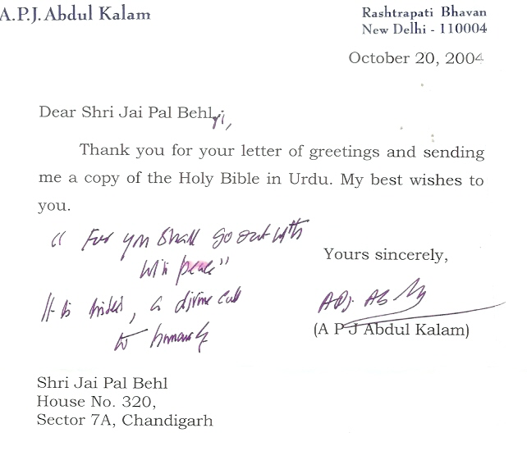
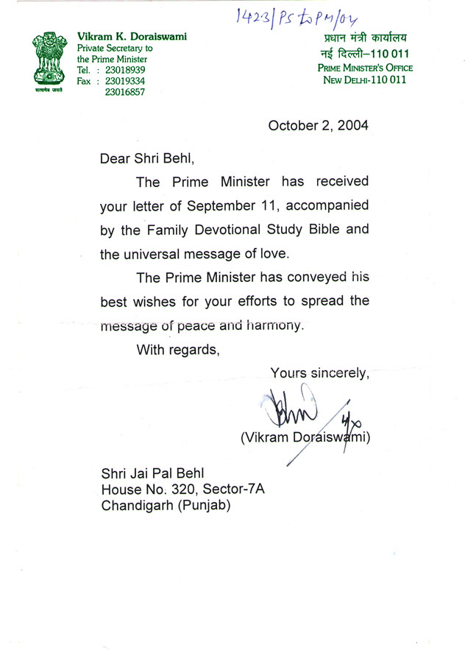

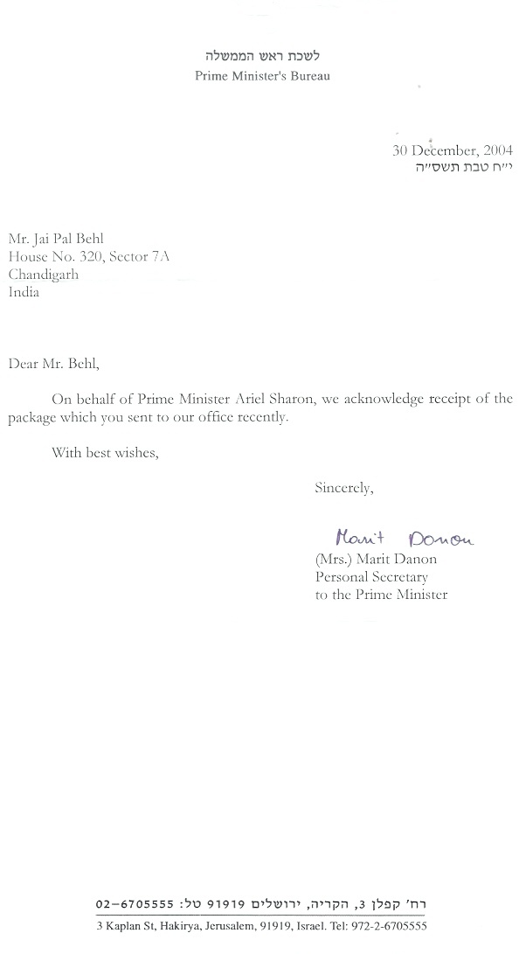
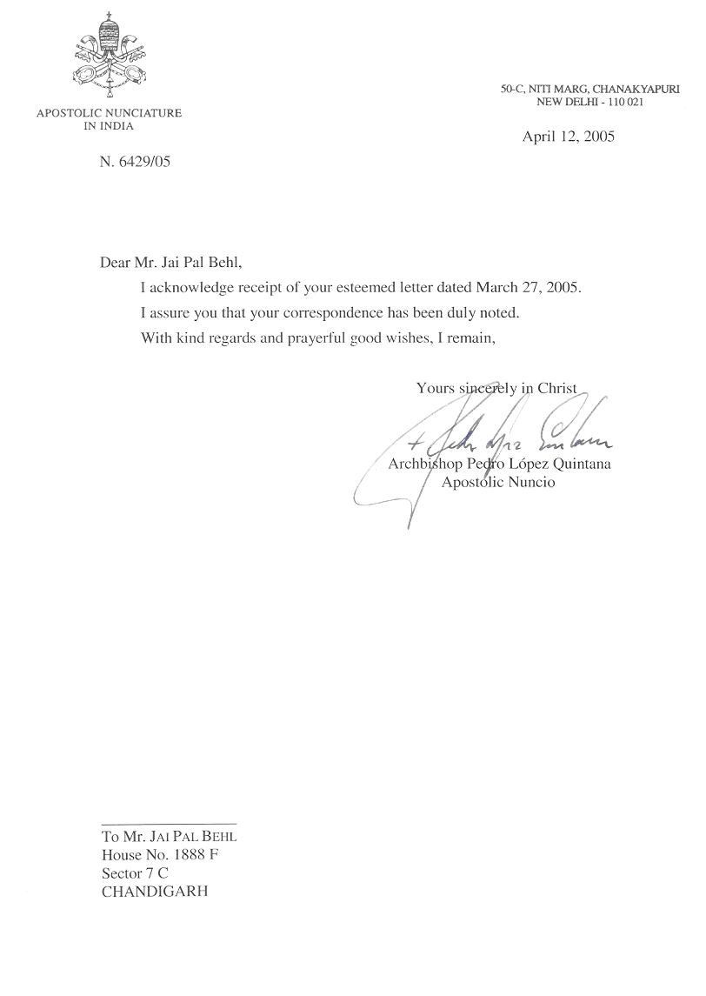
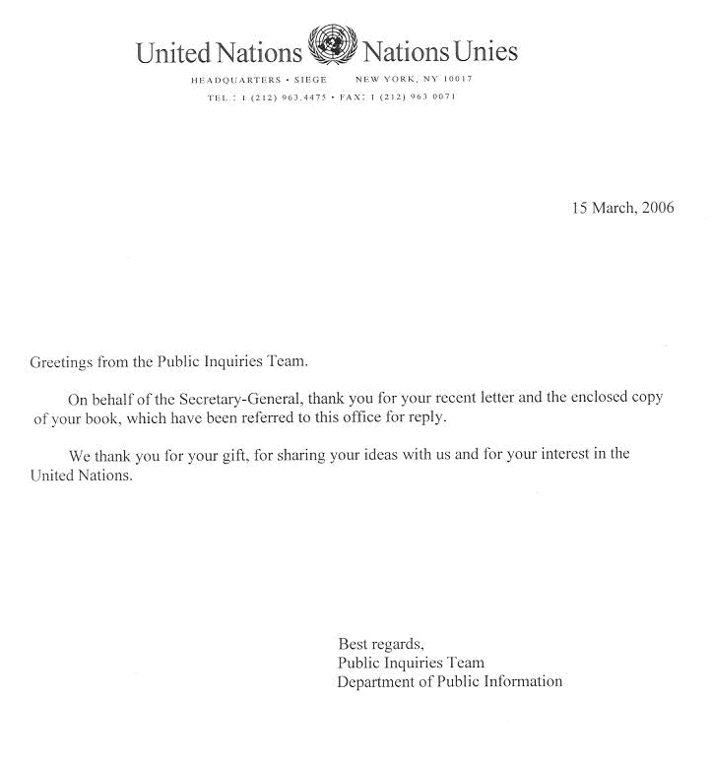
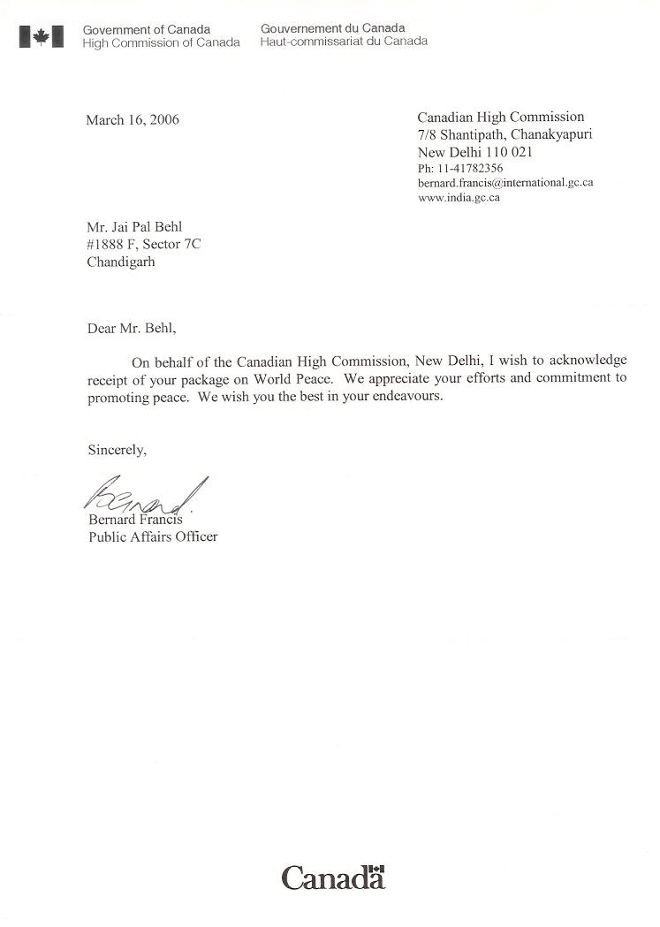

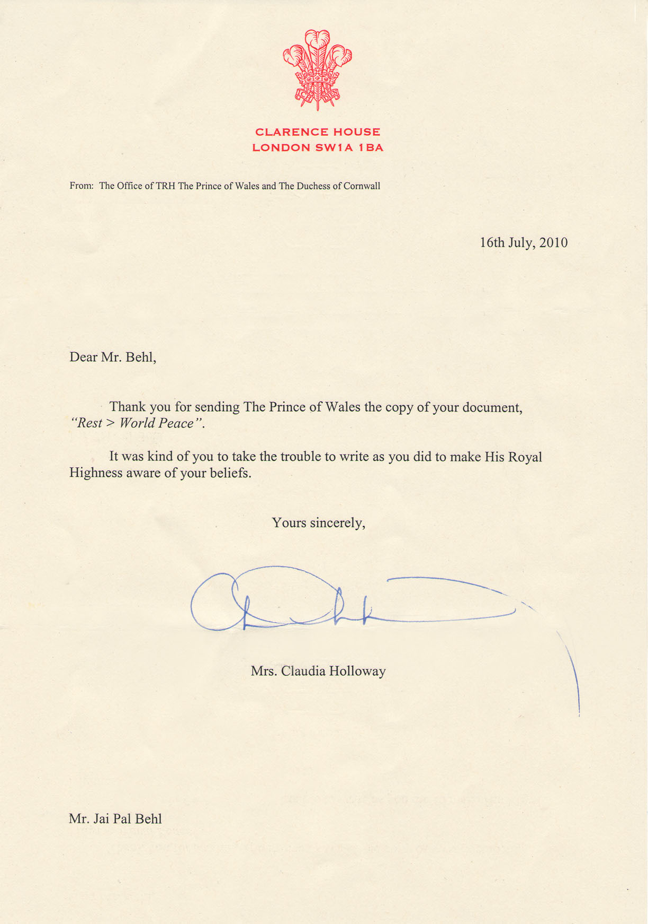

‘PAIGAM’
The Story of a Jewel Thief
Who becomes a good and great person through repentance.
The repentance gives him the golden key of faith in God whereby he achieves divine ecstasy.

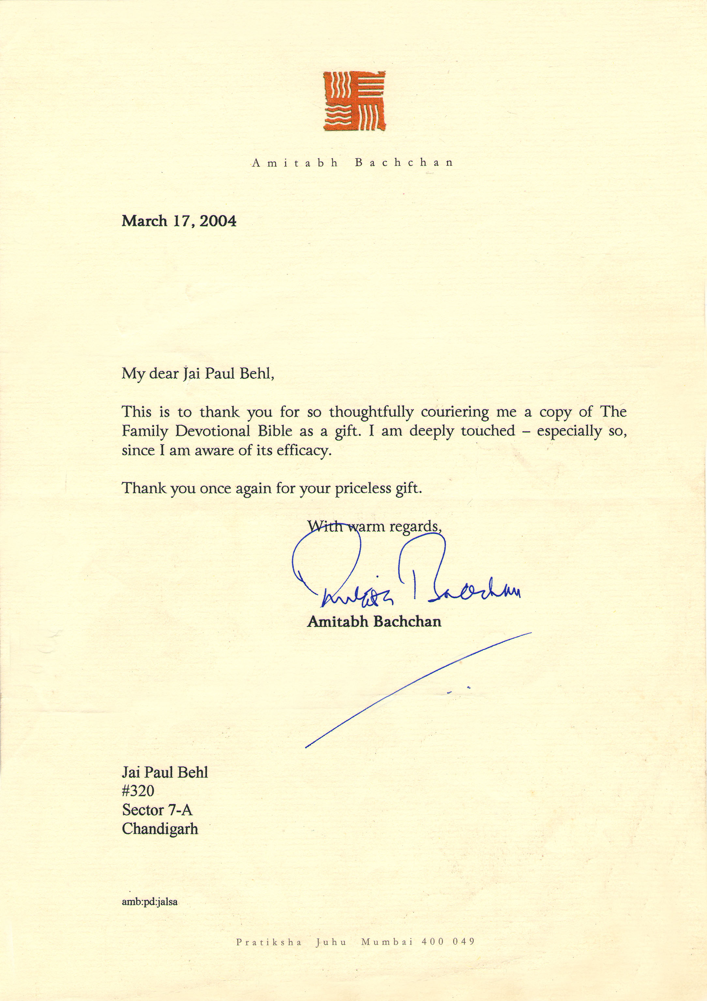
FOR I AM THE LORD YOUR ALMIGHTY GOD, THE HOLY ONE AND SAVIOUR.
Long life is in my right hand; in my left hand are riches and honor (Proverbs 3:16).
I have called you by your name, you are Mine, even to your old age, I am He, and even to gray hair, I will carry you. (Isaiah 40-46)
I will keep you from all harm – I will watch over your life; I will watch over your coming and going both now and forever. (Psalm 121).

Respected Shri Amitabh Bachchan Ji,

May your Birthday be a special time to remember all treasured memories, an occasion to celebrate yourself, and be filled with happy moments to cherish lifelong. Happy Birthday.

Your all pictures and songs have magic power and itself acts a medicine, which touches our heart. There is simplicity in your all pictures, untiring faith of wife towards her husband, natural love and affection with each other. God may shower His blessings on your work and grant you long life with good health, so that you may enlighten to all with 'Madhushala' a celebration of the joy of life the language of 'eternal true love' which was honored your father with the Padama Bhushan for his immense contribution, continue go on prospering and never decrease at all. Amen.

I bring to show you real the Greatest Love Story of the world. There is neither any script nor any humor. It is based on the blessings of the Lord, which intends depicting the two aspects i.e.
- “The Greatest Love Story of the World” (ii) “Paigam” (The Message) for the World Peace.
I come to you in the name of LORD, and with the desire of sharing his teachings with you. The book, Bible contains both the Old Testament and the New Testament. The Old Testament was God’s Word, as spoken to his people before the death of Christ. The New Testament therefore represents God’s Word for his people after the death of Christ. God speaks today; he speaks through his son; and Christ speaks through the written word. That word is recorded in the pages of the New Testament. His word is Spirit and life; it is quick, powerful, truth and forever. God tells us our Sin, of Christ who died for us. (This is the Greatest Love Story of the World) and of the salvation that we can have through Christ.
- ‘PAIGAM’ (The Message). On your birthday, a message for Universal Peace is revealed to me and feeling blessed. ‘Paigam’ is the story of a Jewel Thief who becomes a good and great person through repentance. He admit God that he need help in order to live his life rightly, God fill him with His Holy Spirit and to give him power. The repentance gives him a golden key of faith in God whereby he achieves ‘Divine Ecstasy’.

One of the ugly aspects in the Indian Films is to have shown the followers of Christ under the influence of wine, whereas on the other hand the bright side of Christian’s principles has been depicted in the Hollywood Films by way of examples “BENHER” which was declared to Oscar Award Winning Films.

I enclosed Feature Film “Paigam”. That this message from Almighty God should get disseminated through you on movie screen. I am very confident that this message leads masses from darkness unto light. God wants people to know that he is searching like a shepherd and waiting like a father to receive those who want to come to him. He is willing to forgive and accept at his children all who will live by the simple plan he has given. God invited us to get involved with Him in His Work. God has a big purpose for our life – a very specific and significant calling for us to fulfill. You are seem to be the gifted man sent by God. As you have created so much awareness through movies.

“HAR KADAM MANZIL KOI AWAZ DETI HAI MUJHE,
ZINDAGI HAR DIN NAYA EK ‘PAIGAM’ DETI HAI MUJHE”

Enclosed: 1. 'PAIGAM' A MESSAGE FOR 'PEACE IN THE WORLD' Yours Sincerely
2. Holy Bible
Jai Pal Behl
Chandigarh, the city of peace (India)
‘PAIGAM’ (The Message)

is the story of a jewel thief who becomes a good and great person through repentance.
The repentance gives him the golden key of faith in God whereby he achieves divine ecstasy.
Though he has physically died but spiritually he is very much alive

The story begins when the jewel thief, a young man entering a showroom in the late evening with the intention of stealing some costly ornaments. He takes him no time in stealing a gold necklace and went out the showroom. On coming to know of this the owner of the shop immediately informed his Guard and also the police to catch hold of the thief.

Incidentally he enters a place which is a church. And it being a Sunday evening, the followers have gathered there to listen to the sermons of the Father (Priest) The father of the church (Mr. Amitabh Bachchan) sitting on a wheel chair, being 80 years old.

When the jewel thief enters the church he finds that the Priest of the Church is delivering a message of God about the importance of “CROSS”. He is explaining to the believers that God sacrificed his son “Jesus” on the cross. As such, the cross is a symbol of sacrifice, pain and death to which Christ was subjected. We should not think of the “Cross” as merely a “Cross” but as something which denotes and conveys the sacrifices which to Christ has made to spread the message of God, “TO LOVE HIS PEOPLE”. “Love does not mean here merely sensual /sexual physical pleasures and enjoyment which the modern youth derive from it. On the contrary, it is to make sacrifices and feel one’s greatest sense of responsibility for which God has sent us on earth. So, we should not put “Cross” on our bodies considering it as a silver or gold ornament but wear it as it be wearing “Jesus Christ” himself on our bodies. After finishing his sermons, the father of the church, addressed the believers and said: May God - bless you as you discover more about your purpose of life and the importance of dying to self each and every day”.

When the gathering is over, the people noticed that police are standing outside the church and they are focusing their attention particularly on the jewel thief. When the turn of jewel thief comes, he, himself is thinking in his mind as to what will happen next as he is afraid of the police. He immediately started to silence prayer. He at once inspired by God and boldly asked the police what they wanted? The police tell him that they are looking for the man who has stolen golden necklace from the shop. He explains to them people do not come here with any wrong intention but on the other hand, and they come here and pray to God to grant them forgiveness by their repentance of their past sins.

On that evening, the Jewel Thief was so much moved by the sermons of the father that he spent the whole night sleeplessly while he wearing the same cross. The “Paigam” (The Message) which he had received from the priest, gold necklace, and Cross kept rotating in his mind, one after the other.

The very next morning, he rushes to the church and says to the Father that he wants to know as to “who was Christ”. He confessed his guilt openly for his has having stolen the chain of gold from the Show-Room. He was so much impressed by the Priest’s teachings which he imbibed from him that he left all together his wicked and bad habits and vices and became a thoroughly changed man. Not only did he return the gold necklace but left all the wicked places which he used to visit.

Then the father sent him particularly to a place in a village in Punjab with a letter addressed to a saintly person.
When he reached the village and tried to find out the same person, he found out that he had already left the village, long ago.
A NEW LIFE

In the meantime, he saw a cottage on fire. When he went closer, he noticed that three persons were caught in that fire. The cottage was in flames as peoples stood helplessly watching as there was no fire department in the village. He asked his people whether they could do anything-about it. No one answered. Then he rushed to the blaze alone and came out a moment later with a small child protected under his coat. He was badly burned and within second the roof caved in and killed the parents.

A kind young woman nurses the young man’s wounds. The love, affection and care and attention which he gets from the nurse makes them tie themselves into marriage. They lived happily together in the village for about six months. Every time both were ready to help the villagers, and also the outsiders. After six months, he expresses his desire to his wife to meet the same Father in Mumbai. His wife tells him that she was in labor and he was glad to knowing this.

When he crossed the village, he couldn’t got a conveyance/bus, then he got a lift in passing by truck, wherein several terrorists were sitting with loaded guns, not aware at all that the truck was going in the same direction wherein a raid was laid down by the police party. An encounter between the terrorists and the police takes near the barrier where in all the terrorists were killed on the spot.

The jewel thief however escapes unhurt and surrender himself. Before the police who took him to the police station considering him as the leader of the terrorists. In the jail he is tortured so much so that he came near death. He clarified his position to the jailor that he have never committed any offence for which he was punished so much, as he was simply a jewel thief and told him how his life took a turning point. His wife was called from the village with the help of the jailor.

When his wife met him, “he told her due to the severe torture inflicted on him he was suffering from severe pain that he will not survive any longer and as such he expresses his earnest wish his wife give birth to a noble son who should continue spreading His God’s message without any break. His wife told him that she did not know as what to do next. He told her that she should go to the Priest in Mumbai and his last words were, “Lord, don’t count this sin against those tortured him, then closed his eyes. After his death, his wife goes to the Father and handed over his letter and narrates father, the whole story. The Father of the Church (Mr. Amitabh Bachchan and his wife Jaya Ji) adopts her at once. After some time she gave birth to a healthy child. When the son grew up, and sent him abroad for further studies, at USA.

On reaching there, he notices that the divorce rate is very high. Even the highly educated persons were following this ugly practice and were violating the commands of God. Due to that, his mind was very much disturbed. One morning, he saw an old man throwing something repeatedly, near the seashore. He approached the old man to know what he was doing. He was casting some tiny fish into the sea, which incidentally had come out of the seashore. The old man took again one such fish into his hand and throw it back into the sea, which incidentally, had been cast ashore in their thousands. He asked again the old man could he save all, one by one like this.

The old man, took again one fish and throws it back into the sea, And looked the Youngman and told:
No doubt, I cannot save all of them but I can surely save this one, and a few others in the line.
THE TEACHING OF GOD’S WORD IS LIKE A ROCK.

At once an idea struck him that he should take one by one such case (divorce). In order reduce this high rate he visited various courts, collected and prepared the list of all such cases. He contacted all similarly effected persons individually and explained to them the greatness and glory of married life. Throughout the world many people are suffering and are very unhappy in their relationship. It was not his intention to solve everyone's marriage problems, but through the word of God to find his original meaning and purpose for the marriage relationship.

He also collected address of an old man 60 plus, who was one of the divorcees. He contacted him and asked him as to that were the circumstances under which he left his family members. The old man who was himself a teacher told that his habit was behaved rudely and harshly with everybody he came in contact and didn't spare his staff-members and even daughter and wife who was staff-member herself. He usually remained under the influence of wine. He was cruel to his family members and used even to beat them and as such ultimately kicked them out of his house for no fault on their part and also told them never to come back to his life, and to pay her lump sum money for their maintenance and which his wife refused to take. As he was narrating his own sorrowful story, tears trickled down his eyes. There upon the young man asked the old man, as whether he wanted to reunite with his family members. The old man said that he would be glad to reunite with them. He told him that by the grace of God he will find them out. The old man gave him a letter, addressed to his wife.

The Youngman wondered here and there and at last he was successful in tracing them out in a hilly area where she was running a school with her daughter. He handed over that letter to his wife which mentioned, this was a letter from your husband, "that he was feeling very sorry for that and has been repenting all-along for leaving his dear family members for no fault on their part. I will be thankful to God if all reunite again". When she read it, she melted down, out of love and affection for her husband. And she invited him respectfully. At last the untiring and unending efforts the Youngman reunites them, and the old man also married his beautiful daughter to him.

Youngman’s wife also encouraged and helping him, to spread the greatness and glory of married life. The Youngman passed the message of God: He explained to the effected persons and interesting and attractive verses of the Bible. God created man and called him “Adam”. God then said: “It is not good for the man to be alone. I will make him a helper as his counterpart.” Man needed some one to meet his need. So God put Adam to sleep, took a rib from his side, and built a woman. Then God brought the woman to Adam. Adam exclaimed, he said, “This is bone of my bones and flesh of my flesh”. This declaration is so intimate and touching, the verse goes on to say, “This one shall be called woman because out of Man this one was taken. Therefore a man shall leave his father and his mother and shall cleave to his wife, and they shall become one flesh”. That was the beginning of marriage.

The woman was made for fulfilling a need of man. For this reason she is the treasure of husband. Imagine a doctor doing a complicated operation and he needs from help and advice. Who will he ask for help? The sweeper? The Cook? No. He will ask equally or even more qualified doctor to help him. In the same way, the wife is created to be an equally (or even more) qualified helper for the husband, so that together they can accomplish the task God has given in life to do. God teaches husbands and wives to work together as a team. They are committed to each other until death (Mathew 19:6; 1 Corinthians 7:39). God Himself is the true love and He is the one who created marriage. The teaching of God’s word is like a rock. He who builds his life on it can never fall, no storm or earthquake will never shake him. God wanted to provide Adam with a partner. He did not make ten women and ask Adam to choose the one he liked best. But God made only one and gave her to Adam.

Adam had no choice in the matter.
The same God has planned only one person for each of His obedient children.


GOD TELLS US THAT HE “HATES DIVORCE” (MALACHI 2:16)

When God created marriage, he intended for 2 people to be together until death. God give the command that a wife not separate from her husband. But if she does, she must remain un-married or else be reconciled to her husband. And a husband not divorce his wife. Because getting the support of anger, Satan breaks the just only one blow, pious relations of husband and wife, who had taken the vow of remains united throughout their life. Love is wonderful thing that God created in this world. God is totally love. Love is not feeling that comes into our heart today, and tomorrow is not there anymore. Love is something that needs to be cultivated everyday, and should never get less, get cold or die, but it should get bigger, should mature and get stronger. True love is able to endure suffering and yet remains sweet and kind. The world today is filled with division, war, arguments hate and hostility. God words says, forgiveness is an act of love. To forgiveness is most beautiful action that one person could do towards others. Divorce resolves the original partnership and allows partner to re-marry. Divorce means a breakdown of an institution that God joined. Divorce came into picture when sin entered the universe.

God tells us that He “hates divorce” (Malachi 2:16). Some conclude that divorce is the only answer. Jesus Teaches against the practice of divorce (Mark 10:2-12) The Pharisees came and asked Jesus, “Is it lawful for man to divorce his wife? And He answered and said to them, “What did Moses command you?” They said, “Moses permitted a man to write a certificate of divorce, and dismiss her”. And Jesus answered and said to them, “Because of the hardness of your heart, he wrote you this precept. “But from the beginning of the creation, God made them male and female.” For this reason a man shall leave his father and mother and be joined with his wife, and two shall become one flesh. “Therefore what God has joined together, let not man separate.” And in the house His disciples asked Him again about the same matter. So he said to them, “Whoever divorces his wife and marries another commits adultery against her. “And if a woman divorces her husband and marries another she also commits adultery.”

So marriage is for more than a piece of paper. It involves love and trust. Piece of paper defines the boundaries of a relationship, but in no way can they express it adequately. Nor can we understand the mystery of marriage by studying a certificate of marriage. The laws and rules in the book of the “EXODUS” show that what God desired from his followers. Youngman and his wife united several broken homes and bring cheer and sunshine into many others. Youngman was not preaching a creed; nor with the advocating a philosophy. Everywhere, the spirit of God was working. All the pastors of the Churches were so much impressed by the teachings of God and invited him to preach this message (Divorce) on stages. At last both husband and wife reached India where the TV Channels took an interview, and Youngman was himself very eager to tell who was behind such a giant figure (mother). He turned his face to mother, with full tears in the eyes and towards the sky. And a beautiful and powerful voice came from Heaven,

‘CHALE AAO MERE PASS, BEKHOF QUABOOL KARKE SUB GUNAH
KARTA HOON WADA TUM SE KIS TARAHA SE BADAL DOONGA ZINDAGI
TUMAHARI PAK KAR KE TUMHEIN PATA TAK BHI NA CHALEGA’

(Come unto me, without any fear, and on confessing all yours sins. I promise you that I shall change your life by making you pious in such a way that you would not be aware of it). I will give you a new heart.

© Jai Pal Behl, 2004
_________________
“COME TO ME, I WILL GIVE YOU A NEW HEART”
(Ezekiel 11:19-20)

God Says, “I will Give them an undivided heart and put a new sprit in them, I will remove from them their heart a stone and give them a heart of flesh. Then they will follow my decrees and be careful to keep my laws. The mention of ‘law’ reminds us that most of the Bible’s moral teaching is presented in the form of rules and regulations. It is not all like a modern text – book on morality which sets out theories and arguments and then leaves the reader to work out his own conclusions. The Bible’s conclusions are pre-set, either ‘Do! Or Don’t!’ The Bible rarely stops to give explanations for its commands. And the reason is plain enough. If God’s will fix the boundary between right and wrong, and if the Bible is his word, explanations are unnecessary. God does not have to justify himself to any-body. Being good is being like God. It is as straightforward as that. So it comes as no surprise when God’s people are told again and again in the Bible to copy him.

The Old Testament’s command, ‘Be holy’ because I am holy,’ is matched by Jesus’ astonishing requirement of his followers, ‘Be perfect, therefore as your heavenly Father is perfect’ (Mathew 5:48). ‘Be merciful; said Jesus, ‘just as your Father is merciful’. He demands us,’ love your enemies’ do good to them. Then your reward will be great, and you will be sons of the Most High, because he is kind to the ungrateful and wicked’ (Luke 6:35-36) St. Paul sums up this aspect of the Bible’s moral teaching by linking the duty to imitate God with a call to copy Jesus, who reflects his Father’s character perfectly. “Be imitators of God, therefore as dearly loved children and live like of love, first as Christ loved us and gave himself up for us as a fragrant offering and sacrifice to God, on the cross” (Ephesians 5:1-2) Holiness is not really just one of God’s qualities. It is the shorthand term the bible uses to describe all of them put together. Holy means ‘different’. God is utterly different from anyone and everyone else. ‘There is no- one holy like the Lord’ (1 Samuel 2:2).

Dears, God is so pure that he cannot even bear to look at evil. The Old Testament- law is so full of rules and regulations which were designed to keep God’s people separate from …. Bible tells us very clearly, that the whole world is under the control of the evil one. Jesus prayed for his followers, ‘My prayer is not that you take them out of the world but that you protect them from the evil one (John. 17:11). St. Paul reminds a special kind of loving us that Jesus went to the cross when we were God’s enemies not his friends (Romans 5:10). This is the kind of love that God’s is, and he calls his people to copy him in their own love lives. St. John, put it very clearly: “Dear friends, since God so loved us, we also ought to love one another”. (John 4:11). Love is grace. This is a difficult concept for modern, because the word has changed its meaning so completely. Bible does not mean gracefulness of movement, but an act or attitude of love.

There are certainly plenty of rules and regulations in the Old Testament, but they are all set in a form work of love. That is because of the Old Testament law is covenant law. In the book of, Malachi 2:15-16. “I hate divorce” says the Lord, “And I hate a man’s covering, himself with violence as well as with his garment,”

In the book of Romans and Ephesians: St. Paul says, let us therefore follow the things where with one may edify another. It is the duty of every citizen of the Kingdom of heaven to promote peace on the earth. He says, if you become angry, do not let your anger all day. Don’t give the Devil a chance. Get rid of all bitterness passion, and anger. No more hateful feeling of any sort. Instead, be kind and tender to one another, and forgive one another, as God has forgives us through Christ. As we explore the implication of God’s commandments for our lives; we will be surprised to discovered that they are not the burden; they are often made to appear, His words is the key to His blessing upon our family, community and nation.

The presence of God, not as philosophical principle, but as an active, strong, and loving Ruler – a God, who makes a difference in our life. The full of love and mercy of the Lord Jesus Christ who has changed our lives, and we discovered Jesus Christ is still alive.

JESUS CLARIFIES HIS RELATIONSHIP TO THE LAW OF MOSES.
“You have heard that it was said…...” he begins, and then concludes, “but I tell you ……”
Jesus revealed the true intent of the Old Testament law, The Fulfillment of the Law:

Jesus disciples came to him, and he began to saying: “Do not think that I have to abolish the Law of the Prophets; I have not come to abolish them but to fulfill them. Murder: “You have heard that it was said the people long ago, ‘Do not murder, and anyone who murder will be subject to judgment.’ But I tell you that anyone who is angry with his brother will be subject to judgment. “Therefore if you are offering your gift after and there remember that your brother has something against you, leave your gift there in front go the after. First go and be reconciled to your brother; then come and offer your gift. Adultery: “You have heard that it was said, ‘Do not commit adultery. But I tell you that anyone who looks at women lustfully has already committed adultery with her in his heart. Oaths: “Again, you have heard that it was said to the people long ago, ‘Do not break your oath, but keep the oaths you have made to the Lord; But I tell you, Do not swear at all: either by heaven, for it is God’s throne; or by the earth, for it is his footstool and do not swear by your head, for you cannot make even one hair white or black. Simply let your ‘Yes’ be ‘Yes’, and your ‘No’, ‘No’, anything beyond this comes from the evil one.

An Eye for an Eye: “You have heard that it was said, ‘Eye for eye, and tooth for tooth. But I tell you, do not resist an evil person. If someone strikes you on the right cheek, turn to him the other also. Love Your Enemies; “You have heard that it was said, ‘Love your neighbor and hate your enemy. But I tell you: Love your enemies and pray for those who persecute you, that you may be sons of your Father in heaven. He causes his son to rise on the evil and the good, and sends rain on the righteous and the unrighteous. Be perfect, therefore, as your heavenly Father is perfect.” Giving to the Needy: “Be careful not to do your acts of righteousness” before men, to be seen by them. If you do, you will have no reward from your Father in heaven. “So when you give to the needy, do not announce it with needy, do not let your left hand knows what your right hand is doing, so that your giving may be in secret. Then you’re Father, who sees what is done in secret, will reward you.

Fasting: “when you fast, do not look somber as the hypocrites do, for they disfigure their faces to show men they are fasting. I tell you the truth; they have received their reward in full. But when you fast, put oil on your head and wash your face, so that it will not be obvious to men that you are fasting, but only to your Father, who is unseen; and your Father, who sees what is done in secret, will reward you. Salt and light: “You are the salt of the earth. And you are the light of the world. A city on a hill cannot be hidden. “Therefore everyone who hears these words of mine and puts them into practice is like a wise man who built his house in the rock. The rain came down the streams rose, and the winds blew and beat against that house; yet it did not fall, because it had its foundation on the rock. Ask, Seek, Knock: “Ask and it will be given to you; seek and you will find; Knock and the door will be opened to you. For everyone who asks receives; he who seeks finds; and to door will be opened. “Which of you, if his son asks for bread, will give him a stone? Or if he asks for a fish, will give him a snake? If you, then, though you are evil, know how to give good gifts to your children, how much more will your Father in heaven give good gifts to those who ask him!”

Dears, the book of Luke tells us: when Jesus finally made and entrance, in an inconspicuous stable, the sky filled with singing angles. Clearly, something was brewing on planet earth. Jesus’ birth literally split history into two parts; we memorialize the event whenever we write a date. Even now, more than 2,000 years latter, the commemoration of Jesus’ birth still gives cause for a joy. Our feelings of celebration are gentle after shocks, reminders of the remarkable moment when God became a man and lived on earth. He was born in simple animal shelter. This indicates to the world for His love. Jesus came as a humble servant to meet the needs of God’s lost and dying world. Jesus was a companion to the lonely. He was a road map to the lost. He is the tree of life. The green tree reminds us every year, the new life.

Have we no good news, about the son of God, who came from heaven for us!
Jesus though he was rich, yet for our sake, he became poor that through his poverty might become rich (2 Corinthians 8:9).
PRAISE THE LORD!

The Lord as a great and holy God. He is also described as a compassionate father who loves his children.
For God so loved the world, that He gave His only begotten Son, that whoever believes in Him shall not perish,
But have eternal life. John 3:16 is all about God’s tremendous love for each one of us.

Today people ask if God is righteous and loving being, why then is there so much wickedness, suffering and sorrow. Why nation is pitted against nation, why families are divided, why every newspaper is filled with reports of violence, insane acts of brutality and hate, why God would allow storms, war, and all of those things that should cause human suffering. We must go back to very beginning. We must go back to the story of Adam in the garden, back to the first chapter of Genesis. From the beginning nature was not designed to be adverse in any way, but when man sinned part of the punishment was also through problems in nature. Man faces the problem of death, and all of the sorrow. The only way in which we can be set free the guilt of our sin, and its poisonous effects in us, is to have someone bear the punishment for our sin. Jesus Christ came into the world to do just that! “Thanks be to God for the indescribable gift!” (2 Cor. 9:14-15). Salvation is gift and cost nothing but it cost God everything – it cost Jesus His life. Jesus invites whether you are at the top or at the bottom in the world. Whether you are religious or non- religious, whether you are young or old, well or sick, a good or bad, regardless of color of your skin, the country you belong, the language that you speak, and thousand of other things, he want us come and give us rest from our sin. The work of God in the salvation of souls is greater than the work of God in creating the universe. Let us praise him, act of His power.

I am eternally grateful to my parents for their faithful example before me and for also many more things but one of the most enduring blessings they brought into my life was that "God is a Spirit, Infinite, Eternal and Unchangeable."
I am very thankful to my wife Asha, for her faithful companionship and thankful to my daughter Anu, son Vikas and his wife Pooja for encouraging and helping me and praying to spread peace message on the world. We decided to live for society and die for Him, and share Good News that Jesus came from God to be the Saviour of the world dying from into sin. His pierced hands-represents His deepest expression of love for us. He was wounded for us, that our wounds might be healed. He suffered in our place, that our sins might be truly forgiven. I am also very thankful to Doctor – Sh. Jaison, who met me in the CMC Hospital, Ludhiana (Punjab) and he prayed for me: “Father, I know that You created all people and that they are equal in Your sight. My product is designed the solve other problems. Thank You, Father that You have placed with me a gift that is needed by someone in the world today. You have created me for a big purpose. Help me to find to those who need me the most. In Jesus name I pray, Amen.”

I am closing this letter with honors the ‘One’ who has freely gives us perfect gift. He forgives all our sins and heals all our diseases. He redeems our life from the pit and crowns us with love and compassions. Christianity is not a religion for one day of the year; it is the way of life for every moment of every day of the year. The entire message of the Gospel revolves around one historical event: the sacrificial death of Jesus on the cross. God has a big purpose for our life – a very specific and significant calling for us to fulfill. Dears, if God’s Spirit has shown new opportunities to serve Him, take action and fully depend on his help, then every promise, every attribute, every privilege, every comfort, every blessing, every treasury, and every sweet in the book of God is ours. Now God is looking for the characteristics of lamb in his children. To make sure that we do not ‘perish’ of die spiritually, God sent Jesus to bring us to life in him. He is a bridge between man and God. Listen to what he had to say, “Blessed are they that mourn: for they shall comfort.” Jesus himself told, “The harvest is plentiful, but the workers are few. Ask the Lord in prayers, therefore to send out workers into the harvest field” (Luke 10:2).


Dears, Although, I am hear, and you are there, perhaps thousands of miles in between,
But by the spirit of God we can pray together with one accord to make world better.



Peace is the highest value. If peace has been shattered how one can be content?
Peace in the individual leads to peace within the family. Peace within the family leads to peace in the community.
Peace within the community leads peace within the nation. When there is peace within the nation, then there will be peace in the world.

This world may be full of pollution, war, crime, and hate. But inside us, all of us, linger a remnants that remind us of what the world could be like – of what we could be like. We see the good, the beauty in new crops, in flowers, in sunshine, and even in rain. The Old Testament Prophets dreamed of “that day” when creation would be made new. The book Revelation, tells us, it will be come true. The last word is the best news for all of us. “There will be no more tears, and no pain.” St. John vision ended with a view of the glorious new heaven and the new earth (Rev. 21:1). The Bible began, back in Genesis, with a tragic defeat, when humanity, made in the image of God, rebelled. It ends with a reunion – a marriage, revelation calls it. There is a happy ending after all.

God’s love for us is as fresh as the morning sun, and loving father and the Ruler – God who makes difference in life.
Dears, God is good, merciful and faithful. He will never let us down or fail us.

PROMISE

“ See, I will make all things new…..” (Revelation 21:5)

Remember what happened long ago; acknowledge that I alone am God and that there is no one else like me. From the beginning I predicted the outcome; long ago I foretold what would happen. I said that my plans would never fail (ISAIAH 46:9-10).

“For as the rain comes down, and the snow from heaven, and do not return there, but water the earth, and make it bring forth and bud, that it may give seed to the sower and bread to the eater."
"So shall my word that goes from my mouth; it shall not return to me void but it shall accomplish what I please, and it achieve the purpose for which I sent it, “For you shall go out with peace” Says the Lord. (Isaiah 55:1-12).



